Grade level: high school, introductory college

Duration: 90 minutes

Explore sediments:

Tales of change in the sediments of the Kettleman Hills
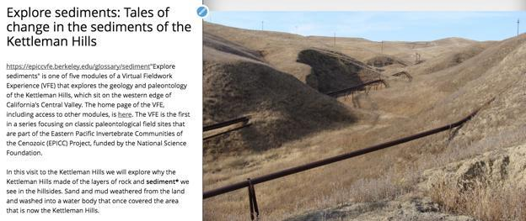

Table of contents

Lesson plan details

Overview

Overarching question

Driving question for students

Module description

Length of activity

Earth science concepts covered

Specific intended learning outcomes

Prior student knowledge

Possible preconceptions and misconceptions

NGSS alignments

Annotated Storymaps module slides

Slide 1: Destroyed and disturbed: Tales of change in the sediments of the Kettleman Hills?

Slide 2: Kettleman Hills outcrops

Slide 3: Observing an outcrop

Slide 5: Investigating the layers

Slide 6: Environmental interpretation through time, starting at the bottom

Slide 7: A little higher in the section and later in time

Slide 8: Getting your nose to the rocks

Slide 9: The upper layers change again

Slide 10: But what about the other features of the outcrop?

1

Lesson plan details

Overview

This module introduces students to making sense of the environmental history of a place by doing virtual fieldwork to interpret layered sediments (or sedimentary rocks) at a real outcrop.

The module uses the slides from the Storymap “Explore sediments: Tales of change in the sediments of the Kettleman Hills” and the Gigapan (gigapixel-size image) “Kettleman Hills - Patinopecten area C.” The Storymap is written for students and contains questions to consider, but suggested specific activities are listed in this document rather than integrated directly into the Storymap text (which provides greater flexibility for the variety of audiences who may visit the Storymap).

Of course, just as there are many possible lessons with any real-world outcrop, there are many lessons you might create using the Gigapan and other images presented here that go beyond this lesson plan outline.

Overarching question

How do we interpret local Earth history from an outcrop of layered sediments?

Much of what we know about the history of the Earth and its life, from climate change through geologic time to patterns of evolution and extinction to large scale tectonic changes are known from interpreting records of layered sediments. It so happens that by learning a few basic principles, students can interpret many of the examples of layered sediments they are likely to come across.

Driving question for students

What happened here to make [typically flat-lying] layers carved, tilted, and slumped?

Module description

Explore an outcrop of sedimentary layers in the Kettleman Hills region, exploring the outcrop both from a distance and close-up as one would in the field. Students will learn to read the history of environments in an outcrop. They will notice fundamental patterns in the outcrop (for example, layering), and then make observations of patterns that crosscut that layers. What was the order of events, and what might the events have been that made this outcrop look as it does?

Length of activity

If done in full may take 90 minutes, but can be adapted to 45 minutes

2

Earth science concepts covered

- Sediment is generally deposited in flat layers.

- Sedimentary layers can be cut, broken, and moved by other geologic processes.

- The sequence of geologic processes that occurred at a place can be ordered in time by the principles of cross-cutting relationships and principle of inclusions.

- Sediment, fossils, and other geologic features (such as sedimentary structures and erosion surfaces) can help us understand the environmental history of a place.

- Like many Earth features, an outcrop looks the way it does because of (1) what happened when the sediments/rocks were deposited + (2) what happened to them when they were buried under the surface + (3) what has happened to them since they have been exposed at the surface.

Specific intended learning outcomes

- Students will be able to point out layers, different kinds of sediment, fossils, and other geological structures in an outcrop.

- Students will be able to form a hypothesis, based on sediment and fossil data and basic principles of sedimentation and erosion, that explains what the environment may have been like when an individual layer of sediment was deposited.

- Students will be able to form a hypothesis, based on data such as a set of layers and cross-cutting relationships, that explains the history of the environment in an outcrop.

Prior student knowledge

- It may be helpful for students to know what a fossil is and to have had a preliminary introduction to types of sediment, deposition in layers, and the principle of superposition.

- Some prior conception that environments and relative sea level can change may also be helpful.

Possible preconceptions and misconceptions

- Students might assume that the shape of the outcrops (and local landscape) is related to the history of the deposition of the layers.

- Students map expect to find, and thus interpret, the shapes of some fossils or other features to be dinosaurs or other large vertebrates.

- Students might interpret recent surfaces of the outcrop (weathering, recent biological activity) as records of the geological history.

- Students may be surprised that sediments several million years old containing fossils have not been lithified into rock.

NGSS alignments

Performance Expectation(s):

- ESS2-2. Analyze geoscience data to make the claim that one change to Earth's surface can create feedbacks that cause changes to other Earth systems.

3

Science & Engineering Practices: Connections to Nature of Science:

- Science knowledge is based on empirical evidence.
- Science disciplines share common rules of evidence used to evaluate explanations about natural systems.

Disciplinary Core Ideas:

- ESS2.A: Earth Materials and Systems: The geological record shows that changes to global and regional climate can be caused by interactions among changes in the sun’s energy output or Earth’s orbit, tectonic events, ocean circulation, volcanic activity, glaciers, vegetation, and human activities. These changes can occur on a variety of time scales from sudden to intermediate to very long-term tectonic cycles.

- ESS2.E Biogeology: The many dynamic and delicate feedbacks between the biosphere and other Earth systems cause a continual co-evolution of Earth’s surface and the life that exists on it.

Crosscutting Concepts:

- Stability and Change: Much of science deals with constructing explanations of how things change and how they remain stable.

- Cause and Effect: Empirical evidence is required to differentiate between cause and correlation and to make claims about specific causes and effects.

NGSS HS-ESS2-2 evidence statements: Observable features of student performance

1 Organizing data

- Students organize data that represent measurements of changes in hydrosphere, cryosphere, atmosphere, biosphere, or geosphere in response to a change in Earth’s surface.
- Students describe what each data set represents.

In Kettleman Hills “Explore Sediments” students will document their observations of ancient sediments in an outcrop that record changes in the geosphere, biosphere, and hydrosphere.

Observable features of student performance will include the following. Students will:

- observe and explore a gigapixel resolution image of an outcrop;

- draw and describe vertical and horizontal variations in sedimentary texture and layers of an outcrop they visit through a gigapixel resolution image;
- draw and describe fossils in the outcrop;

- draw and describe features of an outcrop, such as fractures and weathering, that formed after the sediments had been deposited.

2 Identifying relationships

- Students use tools, technologies, and/or models to analyze the data and identify and describe relationships in the datasets, including:

  - The relationships between the changes in one system and changes in another (or within the same) Earth system; and
  - Possible feedbacks, including one example of feedback to the climate.

- Students analyze data to identify effects of human activity and specific technologies on Earth’s systems if present.

In Kettleman Hills “Explore Sediments” students will use photo-documentation of an outcrop (tools and technologies) and simple models (e.g., principle of horizontality, principle of cross-cutting relationships, relationships between grain size and energy) to document relationships among geologic variables.

Observable features of student performance will include the following. Students will:

- recognize relationships among variables such as grain size, sediment color, existence of fossils, demonstrated in labeled drawings and descriptions; and
- recognize consistent relationships within the outcrop among horizontally layered sediments, tilted sedimentary layers, and vertical fractures, demonstrated in labeled drawings and descriptions.

4

3 Interpreting data

- Students use the analyzed data to describe a mechanism for the feedbacks between two of Earth’s systems and whether the feedback is positive or negative, increasing (destabilizing) or decreasing (stabilizing) the original changes.

- Students use the analyzed data to describe a particular unanticipated or unintended effect of a selected technology on Earth’s systems if present.
- Students include a statement regarding how variation or uncertainty in the data (e.g., limitations, accuracy, any bias in the data resulting from choice of sample, scale, instrumentation, etc.) may affect the interpretation of the data.

In Kettleman Hills “Explore Sediments” students will written explanations and series of drawings to explain interpretations of relationships among variations in the observational data.
Observable features of student performance will include the following. Students will:

- analyze and explain of the order of events that could have yielded the observations of the outcrop at Kettleman Hills;
- analyze and describe uncertainties in interpretations, and suggest additional observations that would help clarify understanding of how the outcrop came to look the way it does; and
- describe limitations in available geological data available at the site for understanding, for example, the exact timing for each geologic process that caused the outcrop to look as it does.

Annotated Storymaps module slides

Blue text is directly from the Storymap, and black text is annotations for teachers.

Slide 1: Explore sediments: Tales of change in the sediments of the Kettleman Hills
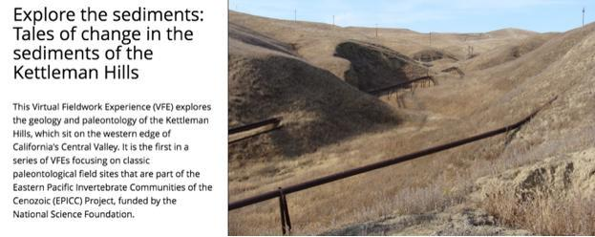

In this visit to the Kettleman Hills we will explore why the Kettleman Hills made of the layers of rock and sediment* we see in the hillsides.

And, in this particular place, what happened to make some layers carved, tilted, and slumped?

5

These are overarching introductory questions that don’t need immediate discussion.

Exploratory activities: If you have time, undertake an activity that allows students to see sediment accumulating in layers. It can be as simple as adding several kinds of sand that vary slightly visually into a transparent container filled with water (such as a fish tank or a glass cylinder).

Slide 2: Kettleman Hills outcrops
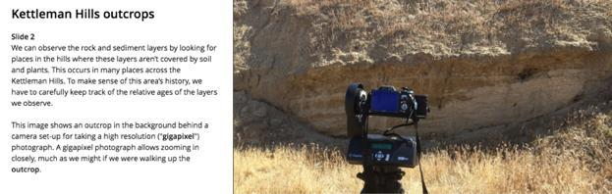

We can see the layers up close by seeking places among the hills where soil and plants aren't covering the underlying layers. This occurs in many places across the Kettleman Hills, and to make sense of the history we have to carefully keep track of the relative ages of the layers we observe.

This image shows an outcrop, with a set-up for taking a high resolution ("gigapixel") photograph that allows zooming in closely, much as we might if we were walking up the outcrop.

This picture sets the context for slide 3.

6

Slide 3: Observing an outcrop
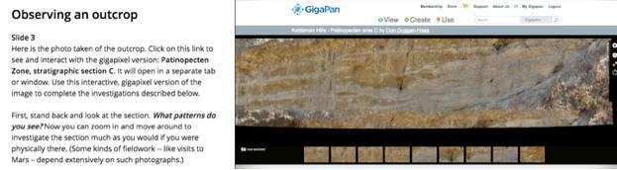

With this image, you can Zoom in and move around, so that you can investigate the section much like you would if you were physically there. (Some kinds of fieldwork -- like visits to Mars -- are entirely dependent on such photographs.)

To get to the image, please click on this link in blue: "Patinopecten Zone, stratigraphic section

C." This will open a new tab on your browser. You can move back and forth between this

Storymap in one tab and a high resolution ("gigapixel") photograph in another tab.

Before zooming in, stand back and look at the section. What patterns do you see?

[If you use the Student Guide, slide 3 is associated with Problem 1a: Document what you observe about the outcrop from a distance.]

Ask students to document what they observe. There are numerous options:

- You can ask students to draw the stratigraphic section, labeling patterns that they notice, which is the traditional method for fieldwork.

- If you have a budget for color copies, you could print copies of the picture of the outcrop and ask students to annotate the copy with arrows, symbols, and labels.

- If students have the equipment and technical skills, students could take a screen grab of the outcrop and annotate it digitally with arrows, symbols, and labels.

- You could project the image onto a whiteboard/Smartboard and have students annotate the image during discussion.

Whichever method is chosen, allow the image to be large enough to hold additional details as additional observations are made.

Please note that students should be labeling their diagrams with observations, but not interpretations -- that will come in slide 6. (Of course, students will have ideas about what they are seeing, but they should not allow themselves to get locked into seeing what they think they should see based on these initial interpretations rather than what they do see.)

Intended student observations:

* layering

7

- at least two colors of layers

- irregularity of layering

- angled bands on right side

- Students might also notice vertical fractures, light colored thin vertical structures, and holes.

Note: There’s no scale in the Gigapan picture, but students can also observe one broad static image from the same outcrop that has a meter-stick in it.

Slide 4: Patterns close-up
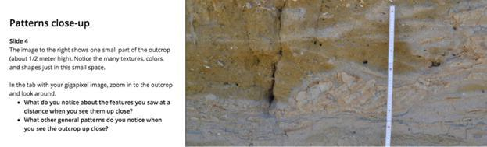

The image to the right shows one small part (about 1/2 meter high) of the outcrop. Notice the many textures, colors, and shapes just in this small space.

In the tab with your "gigapixel" image walk up to (zoom into) the outcrop and look around.

What do you notice about the features you saw at a distance when you see them up close?

What other general patterns do you notice when you see the outcrop close up?

[If you use the Student Guide, slide 4 is associated with Problem 1b: Add additional features of the outcrop to your original drawing, using your observations close-up.]

Ask students to add additional features of the outcrop to their original drawing.

- If space is limited, suggest additional drawings linked back, with arrows or codes, to the original stratigraphic section.

- If students have the equipment and technical skills, they can screen grab zoomed in elements, label them, and map them to a large image.

Intended student observations:

- sediment appears sandy

- layers of shells

- layers of blobs (rip-up clasts); dark rim around light-colored interior

- angled layers within layers (cross-bedding) of some rip-up clasts and shell layers

- might also notice small holes and vertical structures covering layering

8

Slide 5: Investigating the layers
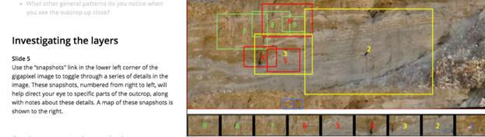

When you investigate the gigapixel image (http://www.gigapan.com/gigapans/190868), you'll notice the word "snapshots" in the lower left of the screen. You can use this to toggle on and off a series of small snapshots of the gigapixel image above. These snapshots, numbered from right to left, will help direct your eye to specific parts of the outcrop for investigating the geologic history that took place here.

A "map" of these snapshots is shown to the right.

There is no activity for this slide other than making sure students understand how the snapshots work in the Gigapan.

Slide 6: Environmental interpretation through time, starting at the bottom
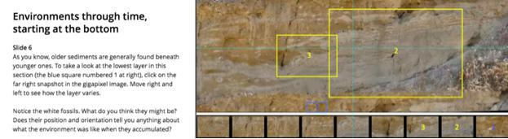

As you know, the oldest sediments are at the bottom. To take a look at the lowest layer in this section, click on snapshot #1 in the gigapixel image, which will take you to that layer.

9

In the image to the right you can see where that image was taken relative to the whole section. When you are zoomed in on the gigapixel image, also move right and left so you can see how the layer varies.

Notice the white fossils. What do you think they might be? Does their position and orientation tell you anything about what the environment was like when they accumulated?

[If you use the Student Guide, slide 6 is associated with Problem 1c: Draw a small portion of a layer with shells. Try to draw the shape of the shells approximately in the orientation you see them in the outcrop.]

In slides 1 through 5, students are making observations of the patterns they see in the outcrop -- reconnaissance observations. In slides 6 through 10 students will observe the outcrop systematically from bottom to top to make interpretations to explain what they’ve seen. Of course, in the process they will make additional observations that refine their interpretation, leading to further observations, and so on. Science is often iterative (rather than linear) in this way.

If you haven’t covered the kinds of fossils found in the Kettleman Hills (e.g., bivalves, gastropods, echinoids, barnacles), you may wish to direct the students to specific slides in the fossils module. You may also wish to show brief videos of these animals living in modern day habitats. You could ask students to indicate in an image that they recognize the shell layers and ask them to draw a small portion of a layer with shells as they see them.

Slide 7: higher in the section, later in time
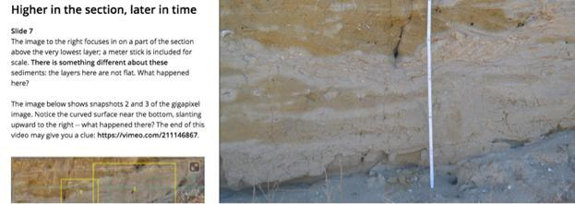

Something happens to the sediments above the very lowest layer: notice that there are patterns that are not merely flat layers. What happened here? The image to the right focuses in on a part of the section that contains some of those patterns. There is a meter stick in the image for scale.

10

The image below shows the snapshots 2 and 3 of the gigapixel image, which can be starting points for exploring this part of the section. Notice in particular the curved surface near the bottom, slanting upward to the right -- what happened there?

[If you use the Student Guide, slide 7 is associated with two problems:

Problem 2a: Write a hypothesis that explains the patterns you saw and described in your drawings for Problems 1a to 1c. Use supporting evidence and ideas for how you would further test your ideas.
Problem 2b: What other sorts of information would you like to collect from the outcrop to be able to test your hypothesis?]

You may wish to have students write a hypothesis, with supporting evidence and ideas for how they would further test their ideas. What other sorts of information would they like to collect from the outcrop?

These are places where flat layers were eroded by running water (a channel cut) and layers then were deposited upon the surface where the erosion took place (erosional surface). Students mostly won’t jump to this conclusion, but they may have creative ideas that can be discussed. A key point is that we can test ideas by observing processes that can be found in nature today, or by doing experiments with sediments in laboratories. You can lead them in the right direct by showing some examples where moving streams, both on land and in water, create channels. The most important point is for students to understand the idea that changing environments leave a record in the sediments that we can use as clues to figure out what happened.

Slide 8: Getting your nose to the rocks
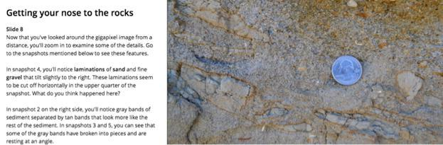

Once you've looked around the Gigapixel from a distance, you'll want to zoom in and look at some of the details.

11

[If you use the Student Guide, slide 8 is associated with Problem 2c: Following are some interesting patterns in the image on slide 8 that are noted in the text on that slide. Answer the questions that are in bold italics below.]

This slide focuses on “sedimentary structures.” Unless this is an advanced or college class, you may wish to skip some of the technical aspects and vocabulary of this slide. You nevertheless may wish to give students a chance to look for interesting patterns and talk about how you would figure out what left them.

You may wish to start by helping students to think about how sediment is transported in moving water. Options include in-class experiments using sand and water, watching sediment move in streams (if one is near the school) or even parking lot drainage on a rainy day, or watching videos.

- Although fancy stream tables can be purchased, inexpensive varieties can be made with students that achieve some of the same goals “Stream Table (in class)”: https://www.youtube.com/watch?v=IIrFDPZ_2Jo.

Here are a few videos showing sediment transport in various contexts.

- "Observe how sediments are deposited": animation of sediment carried by stream and being deposited: https://www.youtube.com/watch?v=jGhogd0G7_U
- "Underwater video of sediment transport in Akutan, Alaska by High Tide Exploration": sediment moving

along the bottom of a shallow channel into sea.: https://www.youtube.com/watch?v=jpexS4-9IF0

- "Sediment transport over ripple beds on oscillatory flow" -- cross section of wave ripples in a flume: https://www.youtube.com/watch?v=g0_vAGiu68c&list=PLUaSVF58nrf-K_K7reRye33Bm8D1WyBHZ&index=135

- "Dynamics of Wave Ripples" - overhead views of wave ripples forming MIT laboratory wave tank (the first part may be useful, close-up showing sediment moving back and forth on the bottom): https://www.youtube.com/watch?v=zRGuMddjRGg

In snapshot 4 you'll notice laminations of sand and fine gravel that tilt slightly to the right, and these laminations seem to be cut off horizontally in the upper quarter of the snapshot. What happened here?

This is an example of cross beds, where moving water creates ripples that leave laminations at an angle. Later more erosion cut off the top of the ripples, leaving just angled laminations with a horizontal surface at the top.
- There are online videos showing how cross-beds form (e.g., https://www.youtube.com/watch?v=KYvWwbEi0A0).

In snapshot 2 you'll notice along the right side gray bands of sediment separated by tan bands that look more like the rest of the sediment. In snapshots 3 and 5 you can see that some of the gray bands have broken into pieces and are resting at an angle.

The close-up image to the right allows you to get a sense of the contrast in the textures among the sediments in the outcrop. Do the gray bands seem to differ in texture from the rest of the layers? How might they have accumulated? And why are some broken and at an angle?

12

The gray bands are made of mud that was deposited on a tidal flat. You can find pictures and videos of the environments along tidal flats.

- "March of the Mudflats" -- time lapse of a mud flat, perhaps in New Zealand (the abundance hermit crabs at this filming locality is not reflected in the fossils record in Etchegoin Fm.): https://www.youtube.com/watch?v=g96JtcliCnk

Some of these bands of sediment have slumped along the edge. The clay was evidently relatively firm and behaved something like a flat rock instead of soft mud.

These are opportunities to learn more about how historical sciences work in trying to figure out how environments have changed through time. Students should feel they can come up with their own ideas and can make sense of geological history.

Slide 9: The upper layers
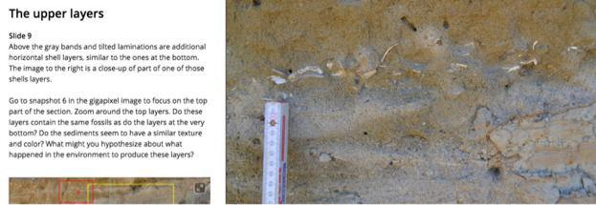

Above the gray bands and tilted laminations are additional horizontal shell layers, perhaps not unlike the ones at the bottom. The image to the right is a close-up of part of one of those shells layers.

In the gigapixel image you can use snapshot 6 to guide you to the top part of the section. Zoom around the top layers. Do these layers contain the same fossils as at the very bottom? Do the sediments seem to have a similar texture and color? What might you conclude about what has happened to the environment?

[If you are using the Student Guide, slide 9 is not associated with a problem; students are requested to “follow the directions in slide 9, rounding out your interpretation of the origin of the whole outcrop.”]

We can’t be sure from the cross-sections of the shells in the Gigapan if the species in the flat upper layer are equivalent to those at the bottom, since we can’t see features often used to define species, but it is reasonable to assume that they might be (students might make

13

observations of size and curvature to test that idea). The simplest explanation for the pattern of layers is that the conditions that led to the deposition of flat-lying layers of sand and shells at the bottom of the outcrop have returned.

Slide 10: But what about the other features of the outcrop?
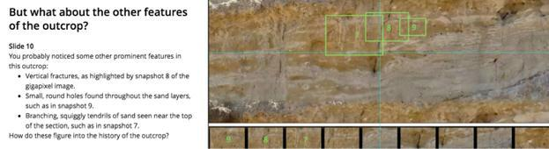

You probably noticed some other prominent features in this outcrop. For example, there are a number of vertical fractures: a good example is in the gigapixel snapshot 8. There are numerous small round holes throughout the sand layers, such as in snapshot 9. Near the top of the outcrop there are some branching, squiggly tendrils of sand such as in snapshot 7. How do these figure into the history of the outcrop?

First it is helpful to ask the age of these features relative to the layers themselves -- did they form at the time the layers accumulated, or sometime afterward? You can answer this question by noticing that these features crosscut the layers -- therefore they must have formed afterward. For that reason, they are not part of the environmental history of deposition of the layers.

Of course, they could still have formed a long time ago and have been a part of the overall geological history. What might cause vertical fractures that extend back into the hillside?

Features that are at the very surface and don't penetrate far into the outcrop probably are associated with recent events. Can you explain the origin of the thin sand trails and the holes?

[If you are using the Student Guide, slide 10 is associated with two problems, including capstone problem 3b:

Problem 3a: Return to the diagram you drew in Problem 1. Use arrows to indicate points on the outcrop where you can find evidence of where the sediment layers, fractures, holes, and sand tendrils cut or otherwise impact each other.

Problem 3b: Revisit the driving question: Summarize the history of this place: explain, in order, what happened at this outcrop to make it look the way it does. What happened here to make [typically flat-lying] layers carved, tilted, and slumped?

14

In geology, when one feature cross-cuts another, we can assume an order of occurrence: the cross-cutting feature must be younger. The vertical fractures, vertical bifurcating sand trails, and holes all cross-cut the layers, and thus are presumably younger. In principle they could have formed soon after deposition, long after deposition while deeply buried, or very recently when exposed in an outcrop. If the features are present only at the surface of the outcrop (they are effectively along the 2-D vertical surface), they are probably recent features caused by weathering and organisms. It’s difficult to know from the photograph alone if these features extend deeper into the outcrops; this is one case in which we need to be physically at the outcrop with a rock hammer to figure it out. In this case, the holes and sand trails seem to be at the surface, and the cracks may extend further into the outcrop.

As a summarizing activity in this module, ask students to write a narrative that explains, in order, what happened at this outcrop to make it look the way it does. This summary might be accomplished in small student groups who compare their observations, or as a full-class discussion. Student work that’s presented or turned in should be supported with field drawings (developed through slide 3 and later) using specific observations. If time allows, enable students to look for observations in videos and images of analogous modern environments that may help them to explain their observations.

We would be grateful to receive feedback on how we could improve this virtual fieldwork experience. If you can spare about 10-15 minutes, please click here. Thank you very much.

15

