Explore sediments:

Tales of change in the sediments of the Kettleman Hills
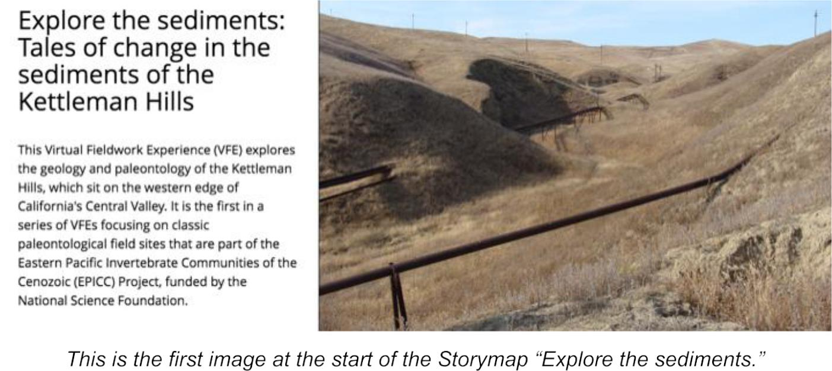

Overview

This module introduces you to the environmental history of a place by doing virtual fieldwork to interpret layered sediments (or sedimentary rocks) at a real outcrop.

The module uses the slides from the Storymap “Explore the sediments: Tales of change in the sediments of the Kettleman Hills” and the Gigapan (gigapixel-size image) “Kettleman Hills - Patinopecten area C.”

Overarching question

How do we interpret local Earth history from an outcrop of layered sediments?

Much of what we know about the history of the Earth and its life are known from interpreting records of layered sediments. By learning a few basic principles, you can interpret many of the examples of layered sediments they are likely to come across.

Driving question

What happened here to make [typically flat-lying] layers carved, tilted, and slumped?

Earth science concepts covered

- Sediment is generally deposited in flat layers.

1

- Sedimentary layers can be cut, broken, and moved by other geologic processes.

- The sequence of geologic processes that occurred at a place can be ordered in time by the principles of cross-cutting relationships and principle of inclusions.

- Sediment, fossils, and other geologic features (such as sedimentary structures and erosion surfaces) can help understand the environmental history of a place.

- Like many Earth features, an outcrop looks the way it does because of (1) what happened when the sediments/rocks were deposited + (2) what happened to them when they were buried under the surface + (3) what has happened to them since they have exposed at the surface.

Prior knowledge

- It will be helpful for you to know what a fossil is and to have had a preliminary introduction to types of sediment, deposition in layers, and the principle of superposition.

- Understanding the idea that environments and relative sea level can change is also helpful.

Red text is directly from the Storymap. Black text is directions.

Slide 3: Observing an outcrop
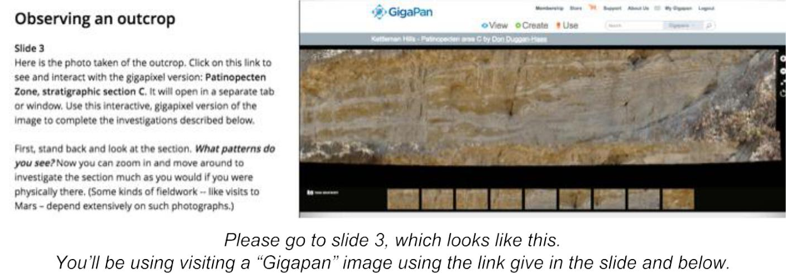

With this image, you can Zoom in and move around, so that you can investigate the section much like you would if you were physically there. (Some kinds of fieldwork -- like visits to Mars -- are entirely dependent on such photographs.)

To get to the image, please click on this link in blue: "Patinopecten Zone, stratigraphic section

C." This will open a new tab on your browser. You can move back and forth between this

Storymap in one tab and a high resolution ("gigapixel") photograph in another tab.

Before zooming in, stand back and look at the section. What patterns do you see?

2

Problem 1a: Document what you observe about the outcrop from a distance.

Draw the outcrop, using the whole piece of paper so you have room for details. Label patterns you notice (but do not write about how you think those patterns formed).

Draw a scale on your diagram. There’s no scale in the Gigapan picture, but one of the broad static images from the same outcrop has a meter-stick in it.

Slide 4: Patterns close-up
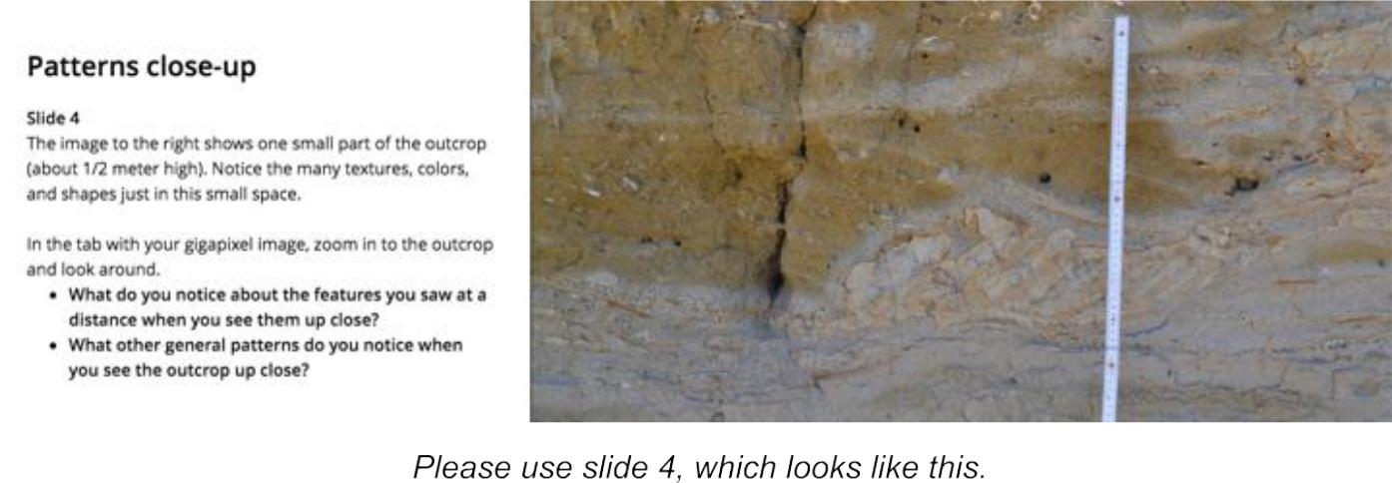

The image to the right shows one small part (about 1/2 meter high) of the outcrop. Notice the many textures, colors, and shapes just in this small space.

In the tab with your "gigapixel" image walk up to (zoom into) the outcrop and look around.

What do you notice about the features you saw at a distance when you see them up close?

What other general patterns do you notice when you see the outcrop close up?

Problem 1b: Add additional features of the outcrop to your original drawing, using your observations close-up.

3

Slide 5: Investigating the layers
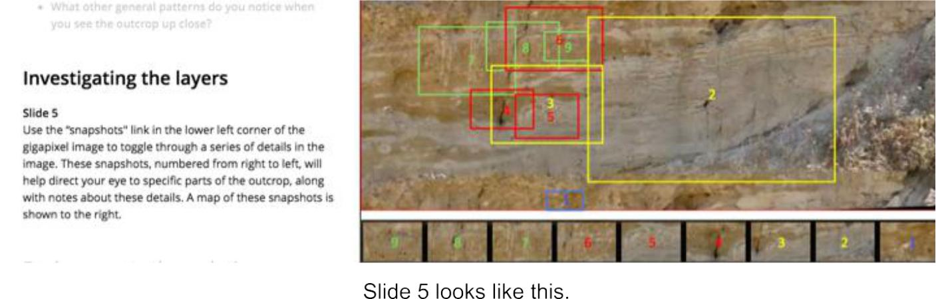

When you investigate the gigapixel image (http://www.gigapan.com/gigapans/190868), you'll notice the word "snapshots" in the lower left of the screen. You can use this to toggle on and off a series of small snapshots of the gigapixel image above. These snapshots, numbered from right to left, will help direct your eye to specific parts of the outcrop for investigating the geologic history that took place here.

A "map" of these snapshots is shown to the right.

Slide 6: Environmental interpretation through time, starting at the bottom
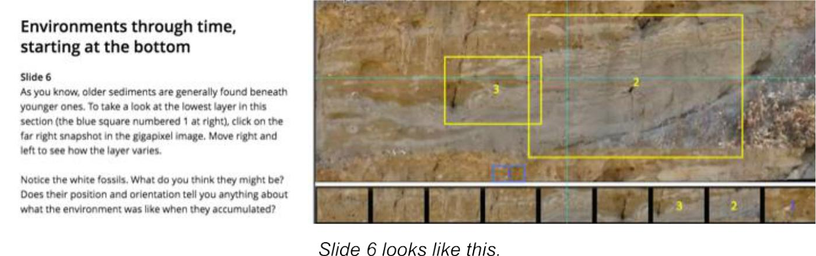

As you know, the oldest sediments are at the bottom. To take a look at the lowest layer in this section, click on snapshot #1 in the gigapixel image, which will take you to that layer.

In the image to the right you can see where that image was taken relative to the whole section. When you are zoomed in on the gigapixel image, also move right and left so you can see how the layer varies.

4

Notice the white fossils. What do you think they might be? Does their position and orientation tell you anything about what the environment was like when they accumulated?

Problem 1c: Draw a small portion of a layer with shells. Try to the shape of the shells approximately in the orientation you see them in the outcrop.

Slide 7: higher in the section, later in time
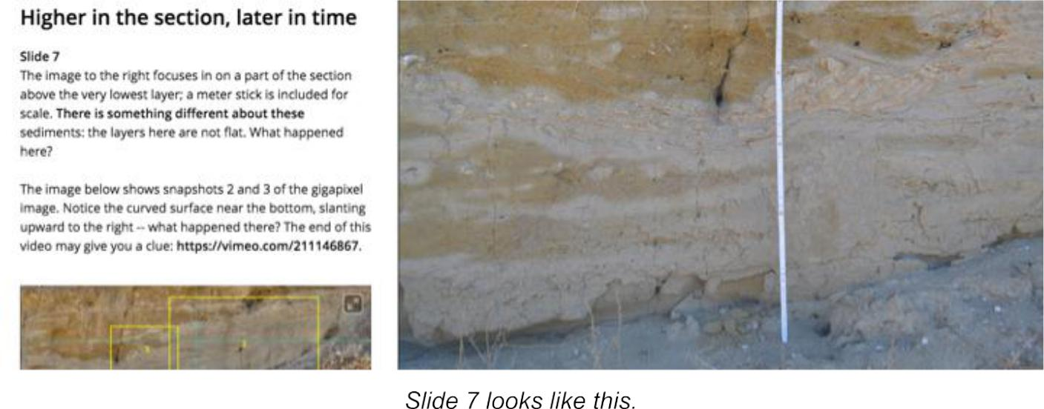

Something happens to the sediments above the very lowest layer: notice that there are patterns that are not merely flat layers. What happened here? The image to the right focuses in on a part of the section that contains some of those patterns. There is a meter stick in the image for scale.

The image below shows the snapshots 2 and 3 of the gigapixel image, which can be starting points for exploring this part of the section. Notice in particular the curved surface near the bottom, slanting upward to the right -- what happened there?

Problem 2a: Write a hypothesis that explains the patterns you see and described in your drawings for Problems 1a to 1c, Use supporting evidence and ideas for how you would further test your ideas.

Problem 2b: What other sorts of information would you like to collect from the outcrop?

5

Slide 8: Getting your nose to the rocks
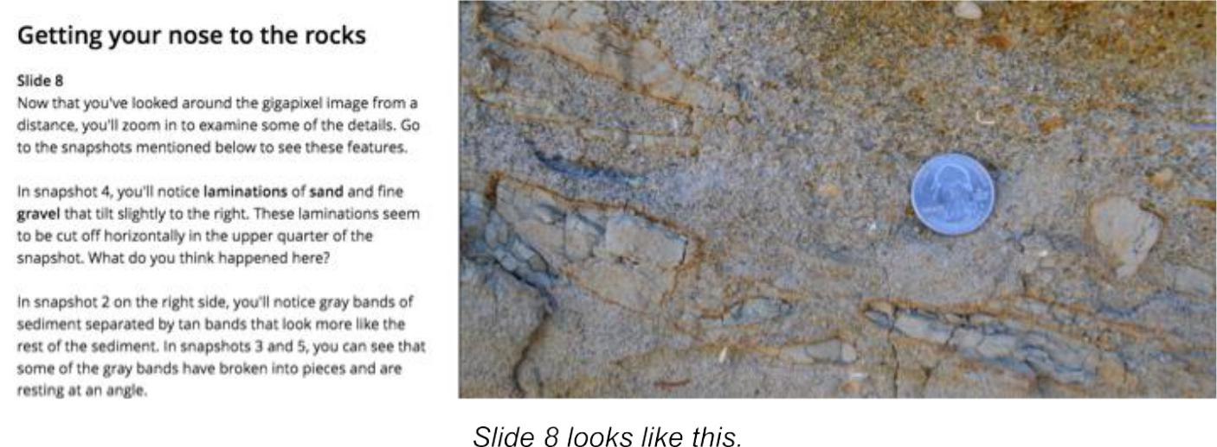

Once you've looked around the Gigapixel from a distance, you'll want to zoom in and look at some of the details.

Problem 2c: Following are some interesting patterns. Answer the questions in bold italics below.

In snapshot 4 you'll notice laminations of sand and fine gravel that tilt slightly to the right, and these laminations seem to be cut off horizontally in the upper quarter of the snapshot. What happened here?

In snapshot 2 you'll notice along the right side gray bands of sediment separated by tan bands that look more like the rest of the sediment. In snapshots 3 and 5 you can see that some of the gray bands have broken into pieces and are resting at an angle.

The close-up image to the right allows you to get a sense of the contrast in the textures among the sediments in the outcrop. Do the gray bands seem to differ in texture from the rest of the layers? How might they have accumulated? And why are some broken and at an angle?

6

Slide 9: The upper layers change again
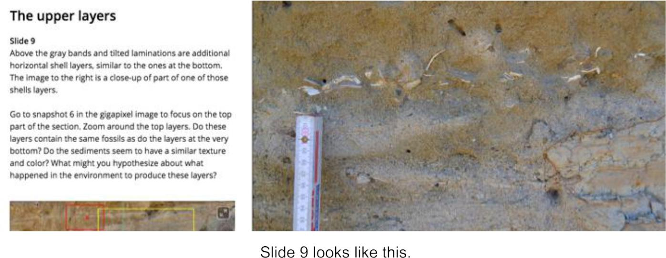

Above the gray bands and tilted laminations are additional horizontal shell layers, perhaps not unlike the ones at the bottom. The image to the right is a close-up of part of one of those shells layers.

In the gigapixel image you can use snapshot 6 to guide you to the top part of the section. Zoom around the top layers. Do these layers contain the same fossils as at the very bottom? Do the sediments seem to have a similar texture and color? What might you conclude about what has happened to the environment?

Slide 10: But what about the other features of the outcrop?
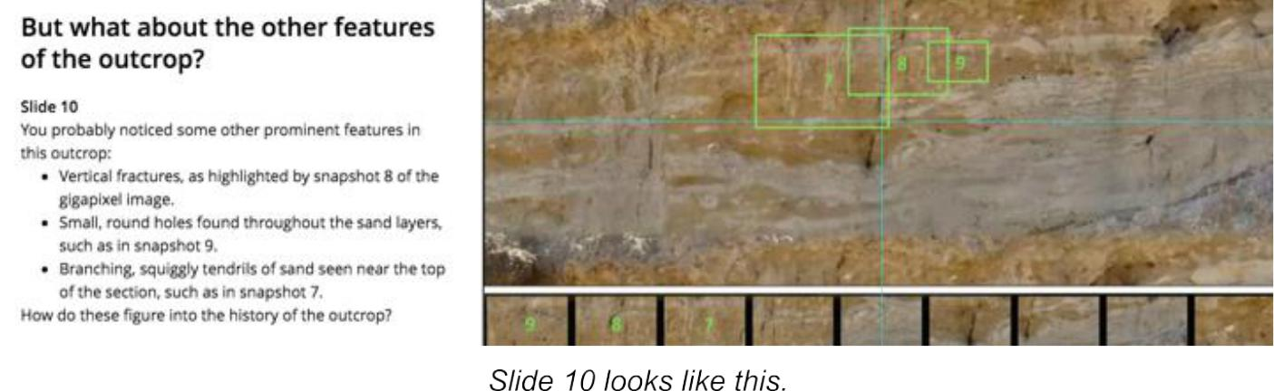

There are a number of vertical fractures: a good example is in the gigapixel snapshot 8. There are numerous small round holes throughout the sand layers, such as in snapshot 9. Near the

7

top of the outcrop there are some branching, squiggly tendrils of sand such as in snapshot 7. How do these figure into the history of the outcrop?

First it is helpful to ask the age of these features relative to the layers themselves -- did they form at the time the layers accumulated, or sometime afterward? You can answer this question by noticing that these features crosscut the layers -- therefore they must have formed afterward. For that reason, they are not part of the environmental history of deposition of the layers.

Of course, they could still have formed a long time ago and have been a part of the overall geological history. What might cause vertical fractures that extend back into the hillside?

Features that are at the very surface and don't penetrate far into the outcrop probably are associated with recent events. Can you explain the origin of the thin sand trails and the holes?

Revisit the driving question: What happened here to make [typically flat-lying] layers carved, tilted, and slumped? That is, explain, in order, what happened at this outcrop to make it look the way it does.

8

