Exploring geology: The story of the rocks and landscape of the Kettleman Hills
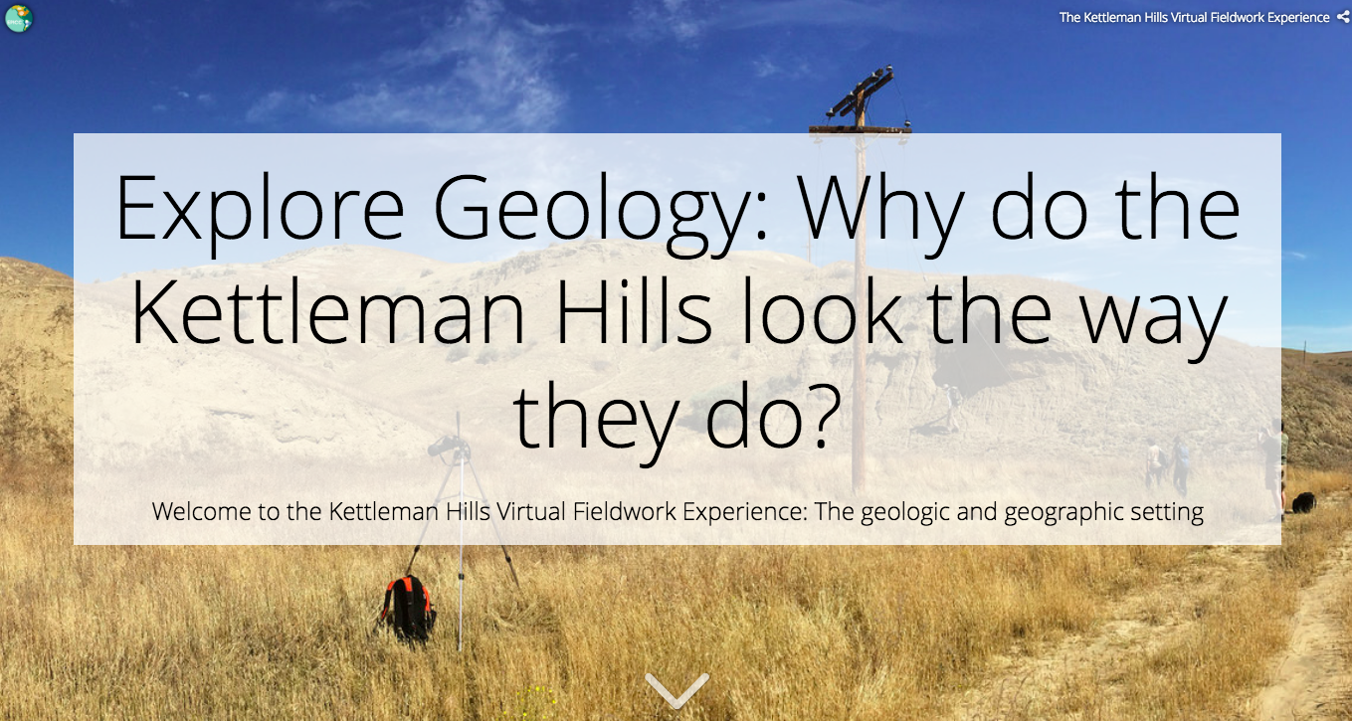

Table of contents
Lesson Plan Details
- Overview
- Overarching question
- Driving questions for students
- Module description
- Length of activity
- Earth science concepts introduced
- Specific intended learning outcomes
- Prior student knowledge
- Possible preconceptions and misconceptions
- NGSS alignments
- Questions raised in the module
- Help us improve this VFE

Lesson Plan Details

Overview
This module introduces students to making sense of the geology and geographic context of a place by doing virtual fieldwork to interpret the geologic and geographic context of a real field site.

The module uses the slides from the Storymap “The Kettleman Hills Virtual Fieldwork Experience: The geologic and geographic context” and related Gigapans (gigapixel-resolution images). The Storymap is written for students and contains questions to consider, but suggested specific activities are listed in this document rather than integrated directly into the Storymap text (which provides greater flexibility for the variety of audiences who may visit the Storymap).

Of course, just as there are many possible lessons with any real-world field site, there are many lessons you might create using the Gigapans and other images presented here that go beyond those presented here!

Overarching question
How can the structure and composition of the rocks and soils in a landscape be used to tell the history of that place? (Or, in maybe friendlier terms, “Why does this place look the way it does?”)

Much of what we know about the history of the Earth and its life, from climate change through geologic time to patterns of evolution and extinction to large scale tectonic changes are known from interpreting records of layered sediments. It so happens that by learning a few basic principles, students can interpret many of the examples of layered sediments they are likely to come across.

Driving questions for students
- Why do the Kettleman Hills look the way they do?
- Why are there sand dollars in the desert?

Module description
Explore the geologic and geographic context of the Kettleman Hills. These hills sit at western edge of California’s Central Valley. The look of the land is typically dry rolling hills cut largely by dirt roads. The dusty brown hills contrast sharply with the flat green (heavily irrigated) Central Valley to the east. Pipes run across the hills reflecting the land’s history of development for oil extraction . Maps and satellite imagery reveal that the set of hills collectively form a boomerang or banana shape. Students will explore and begin to explain the Earth history revealed in the hills - that much of the land was set down in a warm shallow sea a few millions years ago, that it has changed through tectonic forces, by changing climate and by accompanying changes in sea level.

The module may be used as a driver of class or group discussions, or completed as an individual assignment. Not all of the questions raised in the module can be answered just from the content of this module. This is intentional, and suggestive that the module may be more appropriate to drive discussion than to derive a graded assignment. Where content provided is not sufficient to answer a particular question, a different question can be asked and investigated: What else do I need to know to answer this question?

Length of activity
If done in full 90 minutes, but can be adapted for use in a 40 minute class.

Earth science concepts introduced:
- The present is the key to the past.
- Every soil, every rock, and every landscape tells a story as does every component of the landscape.
- Context matters in the interpretation of the stories of soils, rocks, and landscapes.
- Plate tectonic history of a region helps explain the geologic history of a single place within or near that region
- Global changes to Earth’s atmosphere and ocean influence the geologic history of a specific place, for example local sea level and climate

Specific intended learning outcomes
- Students will describe features within a landscape and use those descriptions to infer aspects of a site’s geologic history.

Prior student knowledge
- Some background on climate characteristics will be helpful, though the activity could be used to introduce how climate shapes landscapes.
- It may be helpful for students to know what a fossil is and to have had a preliminary introduction to types of sediment, deposition in layers, and the principle of superposition.
- Some prior conception that environments and relative sea level can change may also be helpful.

Possible preconceptions and misconceptions
- The Earth was created in its present form and has undergone little change.
- Feeling surprise that sediments several million years old containing fossils have not been lithified into rock.

NGSS alignments

Performance Expectation(s):
- ESS2-2. Analyze geoscience data to make the claim that one change to Earth's surface can create feedbacks that cause changes to other Earth systems

Science & Engineering Practices:
- Asking questions (for science) and defining problems (for engineering)
- Constructing explanations (for science) and designing solutions (for engineering)

Disciplinary Core Ideas:
- ESS2.A: Earth Materials and Systems: The geological record shows that changes to global and regional climate can be caused by interactions among changes in the sun’s energy output or Earth’s orbit, tectonic events, ocean circulation, volcanic activity, glaciers, vegetation, and human activities. These changes can occur on a variety of time scales from sudden to intermediate to very long-term tectonic cycles.
- ESS2.E Biogeology: The many dynamic and delicate feedbacks between the biosphere and other Earth systems cause a continual co-evolution of Earth’s surface and the life that exists on it.

Crosscutting Concepts:
- Stability and change. For natural and built systems alike, conditions of stability and determinants of rates of change or evolution of a system are critical elements of study.
- Patterns. Observed patterns of forms and events guide organization and classification, and they prompt questions about relationships and the factors that influence them.
- Cause and effect: Mechanism and explanation. Events have causes, sometimes simple, sometimes multifaceted. A major activity of science is investigating and explaining causal relationships and the mechanisms by which they are mediated. Such mechanisms can then be tested across given contexts and used to predict and explain events in new contexts.

NGSS HS-ESS2-2 evidence statements: Observable features of student performance
1 Organizing data
a) Students organize data that represent measurements of changes in hydrosphere, cryosphere, atmosphere, biosphere, or geosphere in response to a change in Earth’s surface.
b) Students describe what each data set represents.
In Kettleman Hills “Explore Geology”, students will document their observations of landforms. Student performance should be observable. Students will:
- explore, observe, and describe the topography of the Kettleman Hills from multiple scales;
- identify additional observations they would like to be able to make to answer questions about the history of the Kettleman Hills; and
- describe the distribution of rocks in the Central Valley based on geologic maps.

2 Identifying relationships
a) Students use tools, technologies, and/or models to analyze the data and identify and describe relationships in the datasets, including:
i. The relationships between the changes in one system and changes in another (or within the same) Earth system; and
ii. Possible feedbacks, including one example of feedback to the climate.
b) Students analyze data to identify effects of human activity and specific technologies on Earth’s systems if present.

In Kettleman Hills “Explore Geology”, students will identify relationships among their observations of landforms. Student performance should be observable. Students will:
- observe and describe the relationships among human settlements and the Kettleman Hills topography; and
- observe and describe the relationships between climate, landscape, and vegetation, in general and in the Kettleman Hills specifically.

3 Interpreting data
a) Students use the analyzed data to describe a mechanism for the feedbacks between two of Earth’s systems and whether the feedback is positive or negative, increasing (destabilizing) or decreasing (stabilizing) the original changes.
b) Students use the analyzed data to describe a particular unanticipated or unintended effect of a selected technology on Earth’s systems if present.
c) Students include a statement regarding how variation or uncertainty in the data (e.g., limitations, accuracy, any bias in the data resulting from choice of sample, scale, instrumentation, etc.) may affect the interpretation of the data.
In Kettleman Hills “Explore Geology”, students will interpret their observations of landforms. Student performance should be observable. Students will:
- analyze and interpret the origin of the landforms of the Kettleman Hills based on their observations and understandings they may have for how tectonics, weather, and erosion influence landscapes;
- analyze and interpret the origin of marine rocks and fossils in the Kettleman Hills, and thereby interpret the paleoenvironmental history of the rocks, based on their understandings of marine environments and changing sea levels; and
- summarize how the Kettleman Hills came to look the way they do.

Questions raised in the module.
Doing science is an iterative, dynamic process (see Understanding Science for an outstanding review of how science works). The process of science often starts with a driving question -- an overarching question such as “Why do the Kettleman Hills look the way they do?,” or a specific question following a curious observation such as “Why are there sand dollars in the desert of Kettleman Hills?” The questions posed in the module Exploring Geology include a combination of direction observations, interpretations of those observations, and reflections on how we interpret the past. Questions posed to students in the module are listed below, coded by font type according to question type.
- Questions in bold are direction observations of Kettleman Hills VFE images or maps.
- Questions in italics are interpretations of the present and past Earth systems at Kettleman Hills.
- Questions that are underlined are focus on how we use science to understand the geologic past.

A simple student introduction and worksheet is available here. Please copy and edit this worksheet and turn it into a form that suits your purposes.

- Why do the Kettleman Hills look the way they do?
- How can the structure and composition of the rocks and soils in a landscape be used to tell the history of that place?
- Why are there sand dollars in the desert?
- How do scientists - how do you - reveal these ancient stories?
- Initial exploration: What do you see?
- Stepping back - what do you see?
- How would you describe the shape of the hills across a scale of several miles?
- Stepping in - what do you see as we move in closer?
  - What details emerge?
  - What do shapes in the hills remind you of?
  - What processes do you think create different features in the landscape?
  - Why do you think so?
- How does the shape of the land influence the placement of roads and other infrastructure?
- Next, we'll step back out and add geologic information. Keep in mind what you've seen so far and keep focus on the driving question: Why do the Kettleman Hills look the way they do?
  - What questions do you want to ask and answer to help answer the driving question?
  - What do you want to look more closely at?
- What do the appearance of these hills tell you about environments past and present?
- Based on the look of the land, you can make inferences about the climate.
  - Does this look like a place with lots of rain or snow?
  - What are the indicators of the current climate?
- Finding fossils that are very similar to organisms alive today can give very strong hints of what the environment was once like, especially if the organism can only tolerate a narrow range of conditions.
  - In what types of environments are sand dollars found today?
  - What does this imply about the Kettleman Hills' environment at the time the sediment in the hills were deposited?
- The Kettleman Hills are largely composed of marine sedimentary rocks. What are marine sedimentary rocks doing far inland?
- The Central Valley lies to the west.
  - What kinds of rocks are found there?
  - How do they compare in age to the Kettleman Hills? Again, clicking on the map will reveal geologic age of the rock.
- Additional questions appear in the embedded videos.

Help us improve this VFE
We would be grateful to receive feedback on how we could improve this virtual fieldwork experience. If you can spare about 10-15 minutes, please click here.

