Exploring geology:
The story of the rocks and landscape of the Kettleman Hills

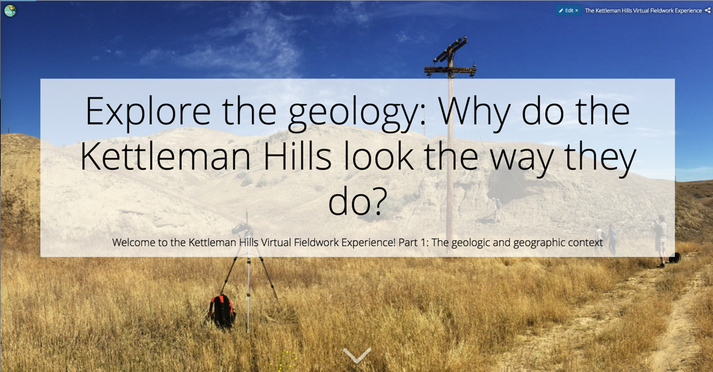

Overview
This module introduces students to making sense of the geology and geographic context of a place by doing virtual fieldwork to interpret the geologic and geographic context of a real field site.

The module uses the slides from the Storymap “The Kettleman Hills Virtual Fieldwork Experience: The geologic and geographic context” and related Gigapans (gigapixel-resolution images).

Overarching question
How can the rocks and soils in a landscape be used to tell the history of that place? (Or, in maybe friendlier terms, “Why does this place look the way it does?”)

Much of what we know about the history of the Earth and its life come from studying the shapes of landforms and the composition of the rock layers they are made of. By learning a few basic principles, you can make sense of the geological history of places you visit, or visit virtually through image and maps.

Driving questions
- Why do the Kettleman Hills look the way they do?
- Why are there sand dollars in the desert?

Module description
These Kettleman Hills sit at the western edge of California’s Central Valley. The look of the land is typically dry rolling hills cut largely by dirt roads. The dusty brown hills contrast sharply with the flat green (heavily irrigated) Central Valley to the east. Pipes run across the hills reflecting the land’s history of development for oil extraction . Maps and satellite imagery reveal that the set of hills collectively form a boomerang or banana shape. Students will explore and begin to explain the Earth history revealed in the hills - that much of the land was set down in a warm shallow sea a few millions years ago, that it has changed through tectonic forces, by changing climate and by accompanying changes in sea level.

Not all of the questions raised in the module can be answered just from the images and maps of this module. In those cases, a different question can be asked and investigated: What else do I need to know to answer this question?

Earth science concepts introduced:
- The present is the key to the past.
- Every soil, every rock, and every landscape tells a story as does every component of the landscape.
- Context matters in the interpretation of the stories of soils, rocks, and landscapes.
- Plate tectonic history of a region helps explain the geologic history of a single place within or near that region
- Global changes to Earth’s atmosphere and ocean influence the geologic history of a specific place, for example local sea level and climate

Your prior knowledge
- It will be helpful to have some background on climate characteristics (such as the differences the vegetation in cold vs warm, and wet vs dry climates).
- It may be helpful to know some basic ideas about plate tectonics..
- Understanding the idea that environments and relative sea level can change will also be helpful.

Questions to answer from the module.
1. The driving questions for this module are “Why do the Kettleman Hills look the way they do?” and “Why are there sand dollars in the desert?” Keep these questions in mind as you move through the Storymap “Explore Geology.”

2. Before you begin, reflect on the question: How can the structure and composition of the rocks and soils in a landscape be used to tell the history of that place? In other words, How do scientists - how do you - reveal these ancient stories?

3. Initial exploration:
a.) In the background photo of the Kettleman Hills, looking north, describe what do you see.

b.) Zooming out, looking at the satellite image with the Kettleman Hills in the background, what do you see? How would you describe the shape of the hills across a scale of several miles?

c.) Zooming in, what do you see as we move in closer to the Kettleman Hills?
What details emerge? Do the shapes in the hills remind you of anything?

4. Now that you’ve made some observations, you can begin to think about the history of the region. What processes do you think create different features in the landscape? Why do you think so?

5. Geologic features have a large impact on people and culture. For example, how do you suppose the shape of the land influence where roads and buildings are built?

6. Next, we'll step back out and add geologic information to answer the driving question, Why do the Kettleman Hills look the way they do?

- What additional questions do you want to ask and answer that could help answer the driving question?
- What would you want to look more closely at?

Now we’ll think about several specific questions that can inform us about the appearance of these hills tell you about environments past and present.

7. Based on the look of the land, you can make inferences about the climate.
- Does this look like a place with lots of rain or snow?
- What are the indicators of the current climate?

8. Finding fossils that are very similar to organisms alive today can give very strong hints of what the environment was once like, especially if the organism can only tolerate a narrow range of conditions.
- In what types of environments are sand dollars found today?
- What does this imply about the Kettleman Hills' environment at the time the sediment in the hills were deposited?

8. The Kettleman Hills are largely composed of marine sedimentary rocks. What are marine sedimentary rocks doing far inland?

9. We can sometimes learn about the geologic history of a place by investigating the geologic history of the places around it.

The Central Valley lies to the west.
a.) Based on the geologic map, what kinds of rocks are found in the Central Valley?
b.) How do these rocks compare in age to the Kettleman Hills? (Clicking on the map will reveal geologic age of the rock.)

10. Revisiting your observations and interpretations, summarize the history of this place: explain, in order, what happened in the Kettleman Hills to make the area look the way it does. Why are there sand dollars in the desert?

