Explore Fossils - Past lives of the Kettleman Hills

Intended audience level: Grades 6-12
Duration: 90 minutes but can be adapted to span two 45 minute activity periods.

"Explore Fossils" is one of five Virtual Fieldwork Experience (VFE) modules that explores the geology and paleontology of the Kettleman Hills, which sit on the western edge of California's Central Valley. The home page of the VFE, including access to other modules, can be found here. The Explore Fossils VFE is one in a series focusing on classic paleontological field sites and is part of the Eastern Pacific Invertebrate Communities of the Cenozoic (EPICC) Project, funded by the National Science Foundation.

In this virtual visit to the Kettleman Hills, students will explore sedimentary rocks rich in fossils and evaluate the evidence supporting claims that changes in environmental conditions in the geological past result in changes in the types of individual fossil species and fossil assemblages.

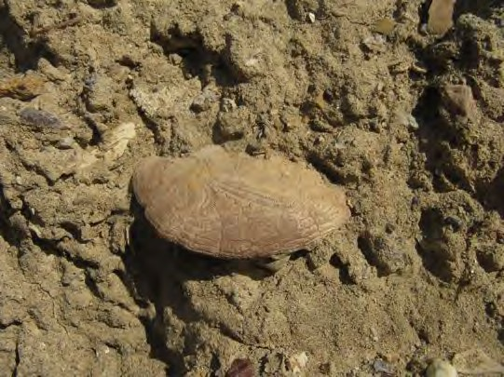
Image of a fossil sand dollar in sandstone from the Etchegoin Formation in the Kettleman Hills

Table of contents
Explore Fossils - Past lives of the Kettleman Hills Lesson Plan Details
Overview Overarching question
Driving question for students
Module description
Length of activity
Earth and life science concepts covered Specific intended learning outcomes
Prior knowledge
Possible preconceptions and misconceptions NGSS alignments

Overview
Lesson Plan Details

This module introduces students to fossils found in the Kettleman Hills geological area of Central California. It uses photographs, diagrams, and other supporting images to guide students in recognizing characteristic features of fossils within a succession of sedimentary rocks and geological formations in which they are found. Slides from the Story Map “Explore Fossils” contain photographs of rocks, embedded fossils, museum specimen photos, and interpretive diagrams to guide students in making observations, asking questions, constructing explanations, and obtaining, evaluating, and communicating information.

Overarching question
How do we use fossils found in sedimentary rocks to determine life of the past and interpret ancient environment of an area? Fossils are the primary means of documenting and understanding life in the Earth’s geological past. Comparing fossils with modern organisms provides evidence and a means to documenting environmental conditions of an area.

Driving question for students
What changes occurred in the Central Valley of California from 4 million years ago to the present day to result in sand dollars and other fossils of marine animals being found in a dry, arid landscape?

Module description
By exploring a series of outcrops of sedimentary rocks in the Kettleman Hills region as a geologist or paleontologist would in the field, students will learn to observe fossils and interpret what their changes over time mean for the history of an area. Students will be introduced to fossils from common invertebrate groups, make observations of individual fossils and fossil assemblages in three different geological formations in the Kettleman Hills area. What patterns of change in fossil record are noticeable here and how do they guide us in understanding the history of the Central Valley of CA (applying the fundamental assumption that natural laws operate today as they have in the past).

Length of activity
The activity may take 90 minutes but can be adapted to span two 45 minute activity periods.

Earth and life science concepts covered
- Fossil are the remains of past life
- Fossils change upward in layered sedimentary rocks (strata or statigraphy) as organisms evolve through time, and characteristic and individual fossil taxa can be used to designate fossil zones (principle of faunal succession; see the Explore Sediments VFE for further information on superposition and original horizontality)
- Units can be grouped into formations and mapped based on distinguishing features of rocks and characteristic fossils
- Changes in the diversity of fossils through time document evolution and extinction of life
- Fossil assemblages, reflecting populations of organisms that lived millions of years ago, together with the sedimentological features of the rocks can be used to interpret past environments.

Specific intended learning outcomes
- Students will be able to describe features within the geological formations they view in the photographs.
- Students will be able to describe specific fossils presented in the different faunal zones and record any similarities, differences, or patterns or change through time.
- Students will be able to draw from information on living organisms and modern environments and use to interpret what the area looked like in the past and how it has changed over time.

Prior knowledge
- It will be helpful for students to know what a fossil is and to have had a preliminary introduction to sedimentary rocks and principles of stratigraphy, superposition (see Explore Sediments).
- Some prior conception of marine environments and familiarity with some modern marine invertebrate organisms is helpful.

Possible preconceptions and misconceptions
- Students might not understand the difference between fossils and rocks.
- Because some fossils resemble modern, extant (living) organisms, students may not be able to distinguish between fossils and their modern counterparts and will be surprised by the age of some fossils.
- Students might think geoscientists' observations directly tell them how things work. Because science relies on observation and because the nature and process of science may be unfamiliar to students, student should be reminded that observation is critical in science but scientists often make inferences about what those observations mean.

NGSS alignments Performance Expectations:
- MS-LS4-1: Analyze and interpret data for patterns in the fossil record that document the
existence, diversity, extinction, and change of life forms throughout the history of life on Earth under the assumption that natural laws operate today as in the past.
- MS-LS4-2: Apply scientific ideas to construct an explanation for the anatomical similarities and differences among modern organisms and between modern and fossil organisms to infer evolutionary relationships.
- HS-LS4-5: Evaluate the evidence supporting claims that changes in environmental conditions may result in: (1) increases in the number of individuals of some species, (2) the emergence of new species over time, and (3) the extinction of other species

Science & Engineering Practices
Connections to Nature of Science:
- Science knowledge is based on empirical evidence.
- Science disciplines share common rules of evidence used to evaluate explanations about natural systems.

Disciplinary Core Ideas:
- LS4.A: Evidence of Common Ancestry and Diversity. The collection of fossils and their placement in chronological order (e.g., through the location of the sedimentary layers in which they are found or through radioactive dating) is known as the fossil record. It documents the existence, diversity, extinction, and change of many life forms throughout the history of life on Earth Science disciplines share common rules of evidence used to evaluate explanations about natural systems.
- Anatomical similarities and differences between various organisms living today and between them and organisms in the fossil record, enable the reconstruction of evolutionary history and the inference of lines of evolutionary descent.
- LS4.C: Adaptation: Evolution is a consequence of the interaction of four factors: (1) the potential for a species to increase in number, (2) the genetic variation of individuals in a species due to mutation and sexual reproduction, (3) competition for an environment’s limited supply of the resources that individuals need in order to survive and reproduce, and (4) the ensuing proliferation of those organisms that are better able to survive and reproduce in that environment.

Crosscutting Concepts:
- Patterns: Patterns can be used to identify cause and effect relationships
- Cause and Effect: Phenomena may have more than one cause, and some cause and effect relationships in systems can only be described using probability

NGSS MS-LS4-1 Evidence statements: Observable features of student performance

- Organize the given data
  - Students use graphical displays (e.g., tables, charts, graphs, and images) to organize given data, including data about:
    - Fossils of animals
    - Fossils of plants
    - The relative ages of fossils
    - Existence of modern counterparts to the fossilized plants and animals and information on where they currently live

In Kettleman Hills “Explore Fossils”, students will document their observations of ancient fossils in an outcrop that records changes in their sizes, shapes, and traits. Student performance should be observable. Students will:
- explore fossils within a gigapixel resolution image

- describe written descriptions of fossils in the outcrop
- draw and describe sizes, shapes, and traits, in order to better understand ancient animal life and their modern equivalents
- observe and describe ancient and modern environments where invertebrate animals live

- Identifying relationships
  - Students identify and describe relationships in the data, including:
    - That fossils represent plants and animals that lived long ago
    - The relationships between the fossils of organisms and the environments in which they lived (e.g., marine organisms, like fish, must have lived in water environments).
    - The relationships between types of fossils (e.g., those of marine animals) and the current environments where similar organisms are found.

In Kettleman Hills “Explore Fossils”, students will use photo-documentation of fossils in an outcrop, museum specimens, and modern invertebrate equivalents to document relationships among fossils across the Kettleman Hills zones.
Student performance should be observable. Students will:

- label drawings and write descriptions that show recognition of any similarities or differences among individual fossil traits;
- label drawings and write descriptions that show changing fossil assemblages occurring vertically in the rock layers and across the fossil zones
- describe features, environments, and habitats of modern invertebrates and how they relate to their fossil counterparts.

- Interpreting data
  - Students analyze and interpret the data to determine evidence for the existence, diversity, extinction, and change in life forms throughout the history of Earth, using the assumption that natural laws operate today as they would have in the past. Students use similarities and differences in the observed patterns to provide evidence for:
    - When mass extinctions occurred
    - When organisms or types of organisms emerged, went extinct, or evolved
    - The long term increase in the diversity and complexity of organisms on Earth

In Kettleman Hills “Explore Fossils”, students will produce written explanations and series of drawings to explain and interpret variations in the observational fossil data. Student performance should be observable. Students will:

- describe the order (succession) of fossils that are in the formations outcropping in the Kettleman Hills
- describe the fossil assemblages (groups of fossils) that are typical in each zone
- explain the changing diversity of fossils through time

MS-LS4-2: Evidence statements: Observable features of student performance

1. Articulating the explanation of phenomena
- Students articulate a statement that relates a given phenomenon to scientific ideas, including the following ideas about similarities and differences in organisms and their evolutionary relationships
  - Anatomical similarities and differences among organisms can be used to infer evolutionary relationships, including:
    - Among modern organisms.
    - Between modern and fossil organisms.
- Students use evidence and reasoning to construct an explanation for the given phenomenon.

In Kettleman Hills “Explore Fossils”, students will produce written explanations to explain similarities and differences in invertebrate organisms found in the Kettleman Hills and their evolutionary relationships. Student performance should be observable. Students will:
- describe specific fossils found in Kettleman Hills (sand dollars, pectens/scallops, snails) and explain how their sizes, shapes, and traits change through time
- explain the causes driving the changes observed in the fossils in each of the formations and zones
- describe the similarities and differences between the fossil sand dollars and scallops and their modern (living) equivalents

- Evidence
- Students identify and describe evidence (e.g. from students own investigations, observations, reading material, archived data, simulations) necessary for constructing the explanation, including similarities and differences in anatomical patterns in and between:
  - Modern, living organisms (e.g., skulls of modern crocodiles, skeletons of birds; features of modern whales and elephants)
ii. Fossilized organisms

In Kettleman Hills “Explore Fossils”, students will use photo-documentation and their own drawings of fossils from the outcrop, museum specimens, and modern invertebrate

equivalents to document variations in fossil and modern life forms. Student performance should be observable. Students will:
- label drawings and write descriptions that show recognition of any similarities or differences among anatomical features and individual fossil traits
- measure and compare the sizes of shells from the zonal marker fossils in each of the zones
- analyze the evidence used in constructing explanations for the differences in fossil clams, snails, and sand dollars observed in each of the zones in the Etchegoin, San Joaquin, and Tulare formations

- Reasoning
- Students use reasoning to connect the evidence to support an explanation. Students describe the following chain of reasoning for the explanation:
  - Organisms that share a pattern of anatomical features are likely to be more closely related than are organisms that do not share a pattern of anatomical features, due to the cause and effect relationship between genetic makeup and anatomy
Ii. Changes over time in the anatomical features observable in the fossil record can be used to infer lines of evolutionary descent by linking extinct organisms to living organisms through a series of fossilized organisms that share a basic set of anatomical features

In Kettleman Hills “Explore Fossils”, students will produce written explanations drawing on evidence supported by observations of features and patterns in invertebrate organisms found in the Kettleman Hills. Student performance should be observable. Students will:
- analyze the anatomical changes observed in the fossils in each of the Kettleman Hills formations and zones
- interpret the evidence supporting evolutionary changes in invertebrate species observed in the Etchegoin, San Joaquin, and Tulare formations of the Kettleman Hills

NGSS HS-LS4-5: Evidence statements: Observable features of student performance

- Identifying the given claims and evidence to be evaluated
  - Students identify the given claims, which include the idea that changes in environmental conditions may result in:
    - Increases in the number of individuals of some species;

    - The emergence of new species over time; and iii.The extinction of other species.
  - Students identify the given evidence to be evaluated

In Kettleman Hills “Explore Fossils”, students will produce written explanations identifying the evidence drawn from fossils found in the Kettleman Hills supporting the changes in species over time. Student performance should be observable. Students will:
- document changes in the individual species and assemblages in the Kettleman Hills formations and zones that lead to claims and interpretations of changing environmental conditions in the geological past
- apply information from observations of modern marine organisms to the interpretation of habitats of fossil organisms
- evaluate the claims supported by evidence from the fossil and modern invertebrates asserting changing environmental conditions over millions of years of geological time

- Identifying any potential additional evidence that is relevant to the evaluation
  - Students identify and describe additional evidence (in the form of data, information, models, or other appropriate forms) that was not provided but is relevant to the claims and to evaluating the given evidence including:
    - Data indicating the change over time in: a) The number of individuals in each species;
b) The number of species in an environment; and c) The environmental conditions.
    - Environmental factors that can determine the ability of individuals in a species to survive and reproduce

In Kettleman Hills “Explore Fossils”, students will research additional sources of information (scientific publications, web resources, video clips) and gather evidence in support of the claims and interpretations of past environments of Kettleman Hills over the past 5 million years. Student performance should be observable. Students will:
- describe the data from additional sources of information that draw from models of environmental conditions in Central California during the Pliocene-Pleistocene
- identify data and data sources that aid in evaluating and understanding the relationships between environmental and habitat change, species interactions, biodiversity, and evolution and extinction
- evaluate all available data in the VFE (sedimentary rocks associated with each formation, fossil assemblages in each of the zones, size changes in fossils through

time) and other sources in support of claims and interpretations of sea level change in Central California.

Questions and guide to the Explore Fossils module

The Explore Fossils module has 24 slides (some with multiple images) with guided questions that are grouped as follows:

Slides 1- 6: Importance and application of fossils
Slides 1-6, collectively, serve as an introduction to some basic geological concepts that are helpful to understanding fossils, specifically those from the Kettleman Hills. Because a significant number of technical terms are introduced, including formal and informal fossil names, students are encouraged to write the definition of the following terms using the glossary provided. These terms can later be incorporated into answers to subsequent questions.

outcrop | sandstone | evidence | evolution | extinction
echinoderm | bivalve | scallop | barnacle | assemblage
zone | formation | Etchegoin Formation | San Joaquin Formation | Tulare Formation

The generalized stratigraphic figure shown below and in Slide 6 of the VFE introduces the three formations exposed in the Kettleman Hills - the Etchegoin, San Joaquin, and Tulare formations and the fossil zones that shape the exercise. Students are encouraged to view the YouTube video by author Lisa White explaining some of the characteristic fossils of the zones.

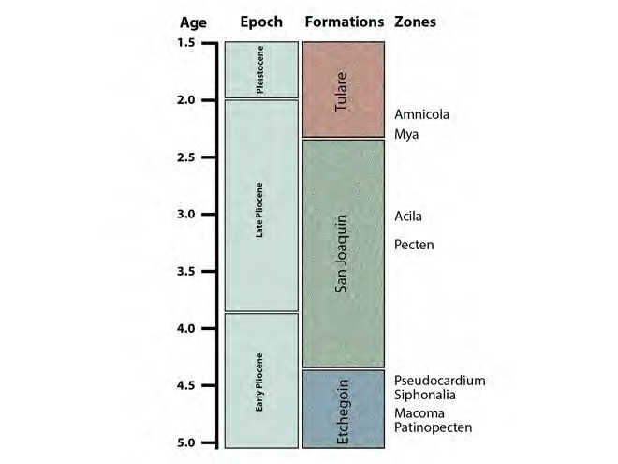

Slides 7-15: Examining fossil zones in the Etchegoin Formation
In slide panels 7-15 students are guided through photographs of Etchegoin Formation outcrops to illustrate features of the sedimentary rocks and the fossils within the rocks. Multiple questions are asked as successive photographs are introduced. Four different fossil zones within the Etchegoin Formation are introduced that are named for a common bivalve (clam) or gastropod (snail) fossil. From oldest to youngest these are the Patinopecten, Macoma, Siphonalia, and Pseudocardium zones. The photographs provided in the VFE show these zone markers and other fossils found in the zones in the field. Museum-quality specimens from the UCMP collection are also provided to better illustrate shell features of the common fossils. Please note these zone names and fossil identifcations follow Woodring, R.P., Stewart, R., and Richard, R.W. (1940) USGS Professional Paper 195.

The students are asked to examine a series of images associated with each of the fossil zones and: (1) describe the rocks found in the section in terms of color and other features visible in the photographs, (2) look for any fossils at a distance in the outcrop and in closer view; and (3) examine photographs of fossils in more detail, describe shell features, and use the space provided to sketch and/or list observations.

Students are not expected to know or use technical terms when identifying shell features; they can use their own words to describe if a shell is smooth or rough, has bumps, folds, or knobs, has a round shape, etc. The goal is for students to notice that each of the fossils for which the zones are named look different and are different fossil genera (singular, genus). Examples of the namesake fossils from photographs in the VFEs are on the following pages. Scale bars and/or size indicators in each of the photographs are particularly helpful for the end of the exercise when students are encouraged to compare the sizes of fossil shells.

As part of the overall introduction to the formations and fossil zones in the Kettleman Hills, students are asked to observe and describe the rocks they see in the outcrop. We recognize students may not have studied sedimentary rocks prior to this exercise or have the vocabulary to detail rock textures and composition. Simple observations of color and if the sand grains are larger or smaller. In general most of rocks in the Etchegoin Formation are brown to tan sandstone. Blue to gray sandstones are found in the Siphonalia Zone and the sandstone are coarser here.

Encourage students to use the boxes provide for sketches of fossils, features of the rocks or outcrops, and/or for written explanations to the questions.

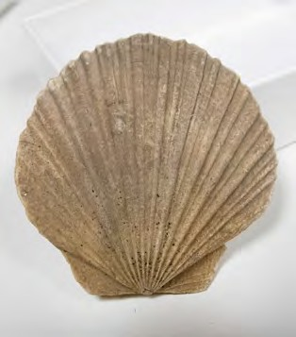
Patinopecten Zone photograph 3 (shell from top to bottom is 7 cm long)

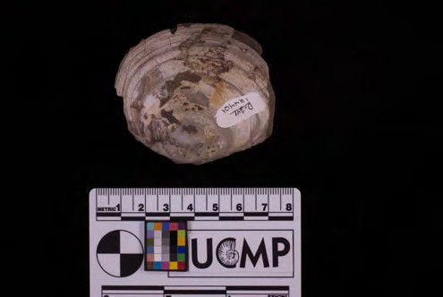
Macoma Zone photograph 3 (scale bar in cm)

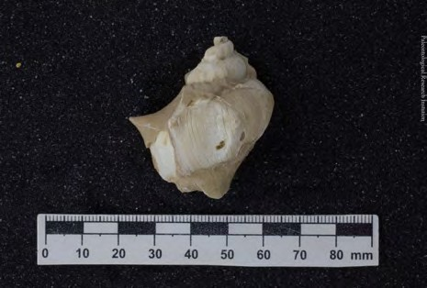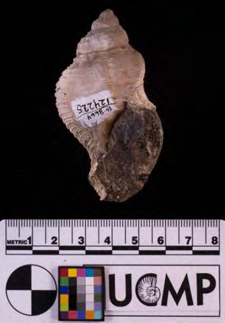
Siphonalia Zone photograph 3 (scale bar in mm) Siphonalia Zone photograph 4 (scale bar in cm)

Slides 16-17: Living Sand Dollars and Living Scallops
After students have learned about assemblages of fossil invertebrates from the Etchegoin Formation, they are encourage to observe the habitats that modern organisms occupy.
While observing the videos they are encouraged to develop a hypotheses about the
ancient environments and ocean conditions of the Kettleman Hills. The leading questions include:

- What are some unique features about the living habits of scallops? Do they live in the ocean, or do they live in lakes?

- Do you notice any distinguishing features of scallop shells that you can use to recognize them and tell them from the other types of clams we have seen?

- The hard shell of the scallop can also be a place where other animals (like barnacles, photograph 1 below) attach as an example of bioerosion. Knowing this, students are encouraged to look for other example of bioerosion throughout the exercise.

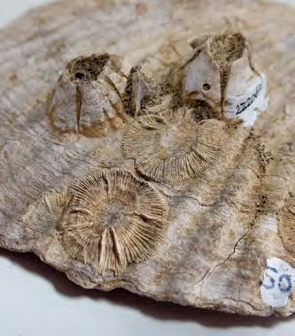
Scallop (Patinopecten) shell with barnacles

Slides 18-19: Examining fossil zones in the San Joaquin Formation
In slide panels 18-19 students are guided through photographs of San Joaquin Formation are introduced to the Pecten (scallop) and Acila (clam) zones. The photographs provided in the VFE show these zone markers and other fossils found in the zones in the field.
Museum-quality specimens from the UCMP collection shown below provided to better illustrate shell features of the common fossils.

Only one rock exposure from the Acila Zone is shown in a photograph and students should note its light grey color compared to brown in the Etchegoin Formation. Sand grains are not as easily visible suggesting the sandstone is finer grained.

Distinguishing features of the fossils marking zones are their smaller overall size when compared with scallop and clam fossils in the Etchegoin Formation.

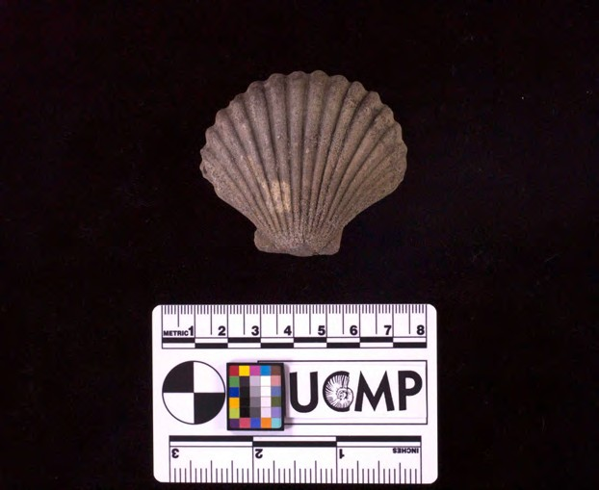
Pecten Zone photograph (scale bar in cm)

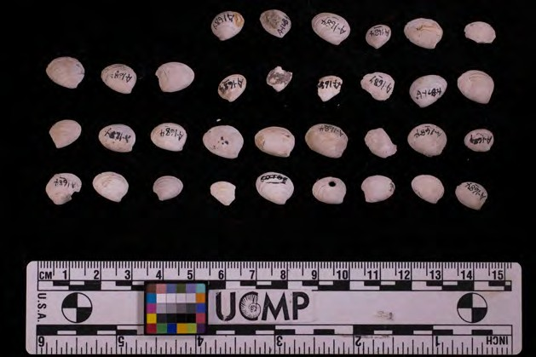
Acila Zone, photograph 1 (scale bar in cm)

Slides 20-21: Examining fossil zones in the Tulare Formation
The Tulare Formation is the uppermost and youngest layers of rocks in the Kettleman Hills. The Amnicola Zone in the Tulare Formation is named for a freshwater gastropod (snail). The rocks are very colorful and distinctive from sandstones in the Etchegoin and Tulare formations. Students should notice this from the outcrop photos provided and also notice how small the snails are relative to fossils snails in the Etchegoin Formation?

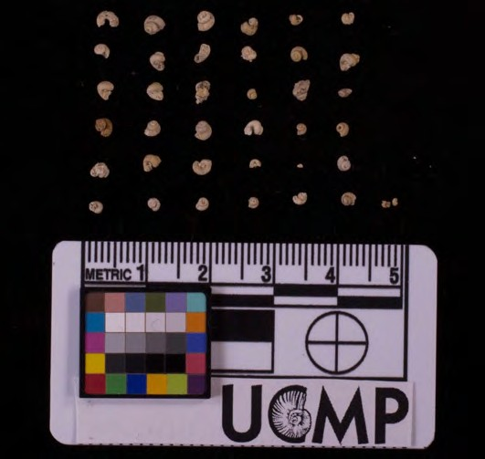
Amnicola Zone, photograph 4 (scale bar in cm)

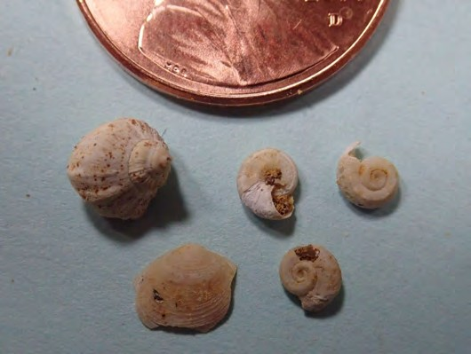
Amnicola Zone, photograph 6 (note penny for scale)

At this point in the exercise students should have sketches, lists, and other notes describing similarities and differences between fossils in each of three formations. These descriptions will be largely qualitative in nature and before proceeding to the final part of the exercise and the environmental interpretations, encourage your student to measure and record the sizes of shells from each of the zones using the table below. A scale bar is provided in most images or a familiar object for students to record size. Ask your students: (1) what are their recorded differences in sizes of fossils in the Etchegoin, San Joaquin, and Tulare formations and (2) what might be the causes of the size changes millions of years ago?

Sizes of fossils from the Kettleman HIlls

Formation | Zone Marker | Common Name | Size in cm or mm (long dimension) | Notes
Etchegoin | Patinopecten | scallop/clam
 | Macoma | clam
 | Siphonalia | snail
 | Pseudocardium | clam
San Joaquin | Pecten | scallop/clam
 | Acila | clam
San Joaquin | Amnicola | snail

Slides 22-24: Environmental Interpretations of the Kettleman Hills from 4 to 1 million years ago

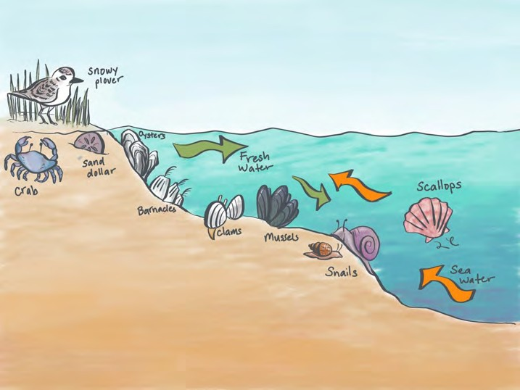
Schematic drawing of modern organisms in shallow water

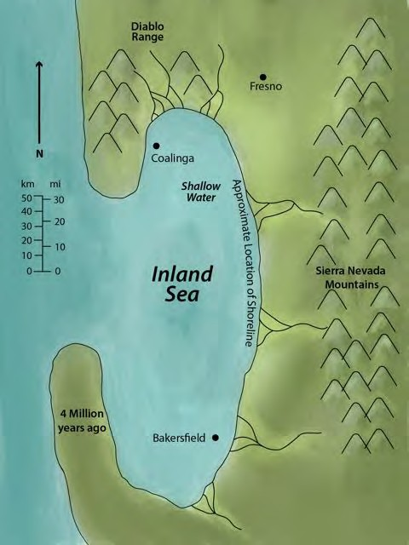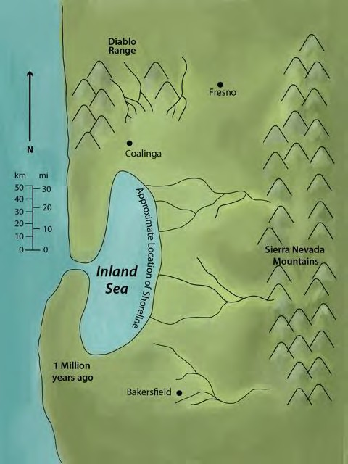
Generalized maps of the Kettleman Hills area in Central California 4 million years ago (left) and 1 million years ago (right)

As students examine the generalized diagrams provided, they are reminded remember that fossils can help us in interpreting past environments. To apply fossils in this way we need know how their close modern day relatives live. Do you recognize any Kettleman Hill fossils in the drawings of modern organisms shown in the figure of the fossil underwater?

As students look at the diagrams in this final section of the module, they should think about the places where animals live and the conditions of the water in those environments. Is it freshwater or saltwater? Was it a lake or the ocean?

Students are asked - what evidence from the fossil record supports the change of environment between 1 and 4 million years ago? They should think about the fossils we saw on our journey through time and the environments those fossils occupied while they were living animals.
Students should use the space provided to explain the changes and relate to the sizes of fossils from each of the formations that you recorded.

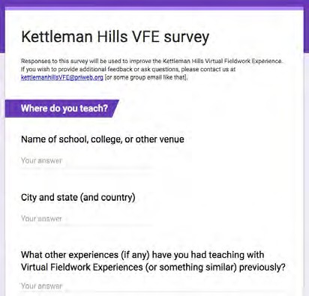We would be grateful to receive feedback on how we could improve this virtual fieldwork experience. If you can spare about 10-15 minutes, please click here.

17
Thank you very much.

