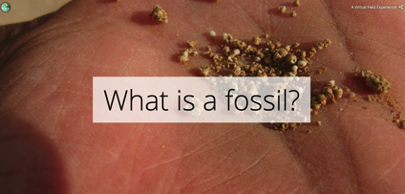
What is a Fossil?
"What is a fossil?" is one of five modules of a Virtual Fieldwork Experience (VFE) that explores the geology and paleontology of the Kettleman Hills, which sit on the western edge of California's Central Valley. The home page of the VFE, including access to other modules, is here. The VFE is the first in a series focusing on classic paleontological field sites that are part of the Eastern Pacific Invertebrate Communities of the Cenozoic (EPICC) Project, funded by the National Science Foundation. This module explores the techniques paleontologists use to identify fossils including the fossils found in the Kettleman Hills.

Table of contents
Lesson plan details
Overview
Overarching question
Driving question for students
Module description
Length of activity
Earth science concepts covered
Specific intended learning outcomes
Prior student knowledge
Possible preconceptions and misconceptions
NGSS alignments
Annotated Storymaps module slides
Introduction
Concept 1: Is this a fossil? How do you know?
Concept 2: Symmetry of fossils
Concept 3: Patterns on fossils
Concept 4: Fossils are often incomplete
Concept 5: Choose a photographed fossil to identify
Concept 6: Solitary and colonial organisms
Concept 7: The present is the key to the past
Concept 8: Kinds of fossils
Concept 9: Classify your chosen fossil
Concept 10: Identify your chosen fossil
Concept 11: Looking at geologic maps

Lesson plan details

Overview
This module introduces students to what fossils are by doing virtual fieldwork to distinguish rocks from fossils and interpret characteristics of fossils shown in photographs. This module is written with middle school earth science classes in mind, though it could be adapted for high school earth science classes using and expanding on the “Challenge” exercises.

The module uses the slides from the Storymap “What is a Fossil?” The Storymap is written for students and contains exercises within the Storymap for students to complete in their field notebook. (For more about field notebooks and their use as a field tool, see the Field to Museum Storymap.) In this module, the field notebook is used to write down answers to questions and make drawings. Students could work quietly and teachers could check their answers at the end or teachers could ask the questions aloud, give students a few minutes to respond and then give feedback on those responses.

Of course, just as there are many possible lessons with any fossils, there are many lessons you might create using the images presented here that go beyond this exercise!

Overarching question
How do paleontologists identify a fossil based on its characteristics?

Driving question for students
If you find a fossil, what steps do you take to identify it?

Module description
Imagine you found a fossil during a field trip. Students will gather evidence to solve the mystery of what the fossil was. They will learn to distinguish rocks from fossils, identify symmetry and other patterns in fossils, and consider how parts of fossils might be destroyed. Students will learn how paleontologists use living organisms to understand fossilized organisms. They will categorize whether their chosen fossil is a vertebrate, invertebrate, plant or trace fossil as well as the general category of marine invertebrate fossil they have discovered.

Length of activity
If done in full 45 minutes, but can be adapted to 20 minutes

Earth science concepts covered
- The present can be used to understand the past.
- Like many Earth features, a fossil looks the way it does because of (1) what happened when the sediments/rocks were deposited on top of it + (2) what happened to them when they were buried under the surface + (3) what has happened to them since they have exposed at the surface.

Specific intended learning outcomes
- Students will be able to identify a rock and a fossil based on photographs.
- Students will be able to gather evidence to explain why a fossil is an invertebrate, an echinoderm or has a certain type of symmetry.

Prior student knowledge
- It may be helpful for students to have an introduction to fossils and to rocks

Possible preconceptions and misconceptions
- Expecting to find, and thus interpreting, the shapes of some rocks or other features as dinosaurs or other large vertebrates.

NGSS alignments
Performance Expectation(s)
- MS-LS4-1: Analyze and interpret data for patterns in the fossil record that document the existence, diversity, extinction, and change of life forms throughout the history of life on Earth under the assumption that natural laws operate today as in the past.
- MS-LS4-2: Apply scientific ideas to construct an explanation for the anatomical similarities and differences among modern organisms and between modern and fossil organisms to infer evolutionary relationships

Selected observable features of student performances
- MS-LS4-1
  - 1b: Students organize the data in a way that allows for the identification, analysis, and interpretation of similarities and differences in the data.
    - Throughout this module, students will use patterns and other characteristics of an organism to compare the organism to others and identify the general group it belongs to (i.e. bivalve, gastropod, echinoid, coral etc.).
  - 2a-ii: Students identify: the time period(s) during which a given fossil organism is present in the fossil record.
    - Concept 8 lists the age of the fossils pictured in millions of years. As an optional activity, students could use a geologic timescale to determine which time period this year falls into.

- MS-LS4-2:
  - 1: Throughout the module, students are asked to use anatomical similarities to infer evolutionary relationships. Specifically in Concept 7, students look for similarities between a modern pill bug and a fossil trilobite, both arthropods. Almost every question related to these concepts asks the student to explain why they gave the answer they did.
  - 2: Throughout the module, students are asked to use evidence they gather to construct an explanation.
  - 3a-i: Throughout the module, students are asked to use reasoning to connect the evidence to support an explanation.

Science and Engineering Practices: Connections to the Nature of Science
- Science knowledge is based on empirical evidence.
- Science disciplines share common rules of evidence used to evaluate explanations about natural systems

Disciplinary Core Ideas:
- LS4.A: Evidence of Common Ancestry and Diversity. The collection of fossils and their placement in chronological order (e.g., through the location of the sedimentary layers in which they are found or through radioactive dating) is known as the fossil record. It documents the existence, diversity, extinction, and change of many life forms throughout the history of life on Earth Science disciplines share common rules of evidence used to evaluate explanations about natural systems.
- Anatomical similarities and differences between various organisms living today and between them and organisms in the fossil record, enable the reconstruction of evolutionary history and the inference of lines of evolutionary descent.

Crosscutting Concepts:
- Patterns: Patterns can be used to identify cause and effect relationships
- Cause and Effect: Phenomena may have more than one cause, and some cause and effect relationships in systems can only be described using probability .

Annotated Storymaps module slides

Blue text is directly from the Storymap, and black text is annotations for teachers.

Introduction
What if you find something that looks like it was part of a living thing?
How do you solve the mystery of what it was?

These are overarching introductory questions that don’t need immediate discussion.

Concept 1: Is this a fossil? How do you know?

- Now it is time to gather some evidence. Evidence is information you will use to solve the mystery.
- What is a fossil? A fossil provides evidence of past life. A fossil could be part of an ancient organism or evidence of the organism’s past behavior, such as a footprint. An organism could be a plant or an animal. A person is an example of an organism.
The definition of fossil, evidence and organism should be discussed if not part of student’s previous knowledge. Definitions are provided in the VFE glossary (https://epiccvfe.berkeley.edu/glossary/).

Is this a fossil? How do you know?
1a) A fossil is something that was once alive. Fossils are often found in rocks, so you need to tell the difference between a rock and a fossil.
See the fossil sticking out of the rock in this photo? Draw what the fossil looks like in your field notebook.
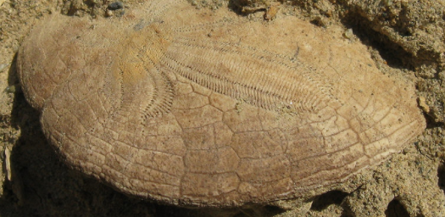
Students should sketch what they can recognize of the fossil echinoderm, its ambulacrum (the pattern on the surface of the echinoderm) and maybe the individual plates which stand out in this specimen.
Are there differences in patterns and textures between the fossil and the rock? What evidence supports your claim? Write down your answer in your field notebook.
Answers could include the difference in the texture of sandstone (grainy) vs. echinoderm (crystalline). The pattern on the surface of the echinoderm also looks different from anything visible in the rock in this area--individual grains in the rock are random in their placement while the echinoderm is made up of calcium carbonate plates organized in a pattern so that the organism can feed, discharge waste, etc.

This is a rock, not a fossil, because it is all made of sandstone. Sandstone is a rock made up of sand.
Take a closer look at the sand grains in the photo below.
Rounded rocks may look like vertebrate bones in general outline, but taking a closer look at the texture allows you to recognize that the shape you see is only sandstone.
This idea of taking a closer look is an important one in paleontology. Scientists often use hand lenses in the field to get a closer look at textures in order to decide if the substance they are looking at was made by an organism.

1b) Is this a fossil? What evidence supports your claim? Write down your answer in your field notebook.
If it is a fossil, draw what it looks like.
Yes, this is a fossil bivalve, a pectinid. On the right is a stylized drawing of a pectinid rotated to a similar orientation of the photo. Students should mention differences in textures between the sandstone and the fossil and show the ridges of the pectinid in their drawing.
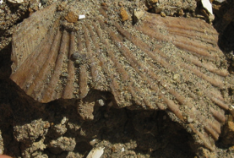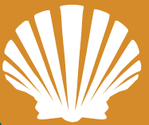
If part of the fossil is missing, fill in what you think was there and explain why you completed the drawing as you did.
Yes, approximately half of the pectinid has been broken off and is missing. The drawing shows how the pectinid might look. Students’ drawing should extend the ridges present in the fossil to encompass the edges. On the right side of the shell, the edges are intact and unbroken, so students should use this to determine how long to make the ridges on the left side of their drawing. Students could also discuss what caused part of the shell to be missing. In this case, it is mostly likely erosion after the shell was exposed on the surface as the broken edges don’t appear rounded as might happen if the shell tumbled against rocks during burial.

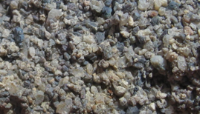
1c) Is this a fossil? What evidence supports your claim? Write down your answer in your field notebook. If it is a fossil, draw what it looks like.
Take a closer look in the photo below.
No, this is a conglomerate, a rock made up of pebbles from other rocks. In the close-up view, you can see how angular the rock grains are. There is nothing that appears to be shell fragments in this rock.

Concept 2: Symmetry of fossils
2) The shape of a fossil can tell you something about what type of fossil it is, especially if you look for symmetry.
- You can look for symmetry by seeing which parts of the body are similar. For humans, the outside of our body is bilaterally symmetrical. That means we have one arm and one leg on the left, and one on the right. If you put a mirror down the middle of a person, each side would look about the same. This is bilateral symmetry.
Optional: students could draw an outline of a human with a dotted line showing the plane of symmetry. This might help them with the following exercises.

What type of symmetry is this? How do you know?
2a) Is this shell bilaterally symmetrical? What evidence supports your claim? Write your answer in your notebook. Make a drawing with a dotted line where the organism is symmetrical.
The progression of three images of the same bivalve specimen should help students to identify that this shell is bilaterally symmetrical.The first image shows the two valves as they would be in life position. The other two images show the valves offset in a way that would only happen after the organism had died.
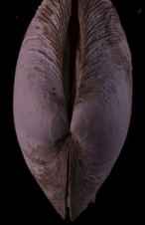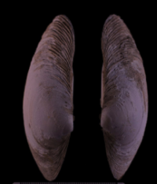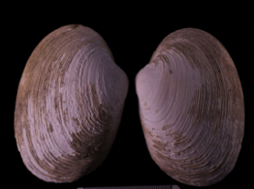

Red dotted line shows the plane of symmetry.

2b) Is this organism bilaterally symmetrical? What evidence supports your claim? Write your answer in your notebook. Make a drawing with a dotted line where the organism is symmetrical.
Yes, this trilobite is bilaterally symmetrical. Dotted red line below indicates plane of symmetry and the organism looks approximately the same on both sides.
Students may ask if there it still counts as symmetry when there are slight differences and it does. Slight differences may be original to the organism itself or be due to conditions of burial or erosion on the surface. For example, the trilobite eye on the top side of the red line is better preserved than the eye below the dotted line, though both probably would have appeared equal in life. Symmetry is connected to the organism’s genes and thus tends to be the same at high taxonomic levels (i.e. most organisms in Phylum Echinodermata have pentameral symmetry).

2c) Challenge: What kind of symmetry does this organism have? What evidence supports your claim? Write your answer in your notebook. Make a drawing and use a dotted line to show where the organism is symmetrical.
This is an echinoderm. Most echinoderms exhibit pentameral symmetry. The pattern on the center of the echinoderm (called the ambulacrum) shows these five parts. Students should discuss the similarity of the pattern on either side of the plane of symmetry.
According to recent research, echinoderms also have bilateral tendencies, suggesting bilateral symmetry might also be a correct answer. (see http://journals.plos.org/plosone/article?id=10.1371/journal.pone.0028978)

(Left) Plane of bilateral symmetry (Right) Planes of pentameral symmetry

Concept 3: Patterns on fossils
3) Patterns on a fossil organism can help you narrow down what the fossil is. A shell might have multiple ridges, and another animal might have multiple segments.

What patterns do you see in this fossil?
3a) Do you see ridges in this shell? Count how many there are and write down the number in your notebook. The number of ridges can be used to help find the name of this organism.
Challenge: Do you see the light and dark banding as you go from the narrowest to the widest part of the shell? These are growth bands, and can be used to estimate the age of the shell.
This pectinid has at least 22 ridges, which are called ribs, and add strength to the shell.

The light and dark banding is probably too subtle to have students count or draw. The bands in shells are somewhat like tree rings in that bivalves continue to add new layers to their shells over their life. Shells with more bands have generally lived longer than shells with fewer bands. Each band doesn’t necessarily mean a year in time. Some shells may deposit layers seasonally, or several times during the year.
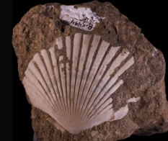

3b) Do you see the segments? Count how many there are in this animal and write down the number in your notebook.
The number of segments can be used to help find the name of this organism.
There are 9 segments on the thorax, see numbered figure below.
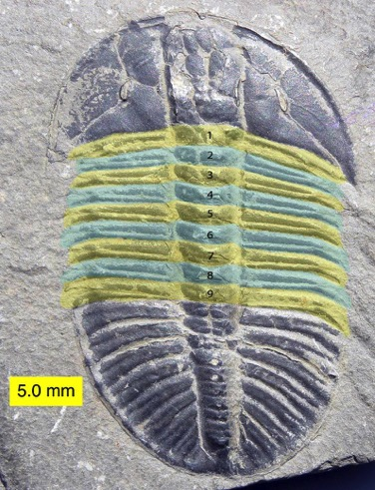
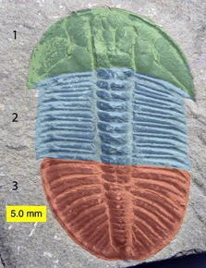
Highlighted in green the cephalon (head) of the trilobite which includes the eyes, highlighted in blue is the thorax of the trilobite, highlighted in red is in the pygidium. In this trilobite, Olenoides, each of the three sections is approximately equal in width.
3c) Does this organism have a pattern? What evidence supports your claim? Write down your answer in your field notebook. If there is a pattern, draw what it looks like.
This is a coral and does have a pattern in the arrangement of the cup-shaped depressions called corallites that hold individual coral polyps (corallites are circled). Corals are colonial--each polyp cannot live on it’s own but plays some role in building the calcium carbonate skeleton that this stony coral has, in feeding or defense, etc.
This question is less about what you can learn from the pattern of the coral and more about learning to recognize patterns in fossils.

Concept 4: Fossils are often incomplete
4) Part of fossils are often hidden or lost, and this add to their mystery.
4a) Look at this shell. Sandstone is covering the right side of it.
What do you think the shell looks like under the sandstone? What evidence supports your claim? Draw the missing part of the shell in your field notebook.
This exercise is similar to 1b). On the right is a stylized drawing of a pectinid rotated to a similar orientation of the photo. The drawing shows how the pectinid might look. Students’ drawings should extend the ribs present in the fossil to encompass the edges. On the left side of the shell, the edges are intact and unbroken, so students should use this to determine for how far the ribs extend.
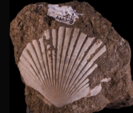

4b) Part of this shell broke off and is missing. Do you see the dark sediment underneath where the shell used to be?
Challenge: Why is the shell broken? How could the shell have been broken before it was fossilized? How could it have been broken after it was fossilized? What evidence supports your claim? Write your answer in your field notebook.
This question asks students to hypothesize what could have happened to break the shell. It requires thinking about the cause and effect. Some possible answers for how the shell could have broken before it was fossilized: during scavenging by a predator, during transport of the shell through the water due a collision with rocks or other shells, or during burial in within sediments. Some possible answers for how the shell could have broken after it was fossilized: damage caused by waves or a storm, damage caused by falling rocks or other debris or gradual erosion due to wind and water action.
The breakage pattern doesn’t appear to indicate predatory scavenging (a crab causes extensive damage to a shell and a gastropod drilling would make only a small hole). As most of the shell is still present and the part missing likely stood up the highest from the rock, erosion once it was exposed at the surface seems the most likely. If the shell was transported through water or crushed during burial, the damage would be more extension.
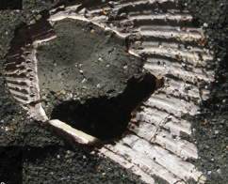

4c) Is this fossil complete or are there parts that are missing or damaged? What evidence supports your claim? Write your answer in your notebook.
This bivalve has a broken shell and also parts of the shell have been removed by erosion (bottom edge, especially on the left side). Students might not be familiar with the shape of a razor clam and thus might not know what is missing. Students who recognize the damage might note the missing piece surrounded on all sides by shell and the outline in the rock beneath the shell that seems to follow the general shape of the shell but is no longer covered by shell material.
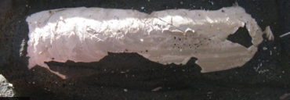
4d) Challenge: What part of the fossil can you see here? What happened to this fossil? What evidence supports your claim?
This is a bivalve shell in cross-section. Around half of the shell has eroded away, but you can still see the two valves and how they are almost connected. This means the shell has not been transported very far from where it lived.
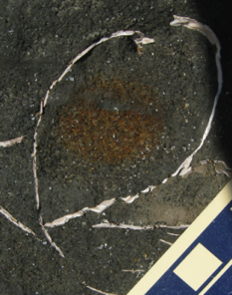

Concept 5: Choose a photographed fossil to identify
5) Now go to this website and choose a photo. Use the student worksheet and what you learned in this module to determine what the fossil in the photo is. Write down your answers to each step, and why you think so, in your field notebook.
For all of the following questions, the students should be answering the questions as they relate to the fossil photo they choose. The website link is to photographs taken for the EPICC project of University of California Museum of Paleontology marine invertebrate specimens. Though the scientific names are present near the photos, students are unlikely to recognize what type of organism is represented by the name, and thus should pursue answering that question on their own. Teachers can use the names on the website to verify whether the conclusion reached by the student is correct.

Concept 6: Solitary and colonial organisms
6) Is the fossil made up of one or multiple living pieces? For example, a coral is made up of many tiny soft coral polyps that live inside the hard coral skeleton. The polyps live in the holes you can see in the photo on the right.
It is most likely students will choose a photo of a solitary rather than colonial organism, but this provides an introduction in case a colonial organism is chosen. See additional explanation in 3c).
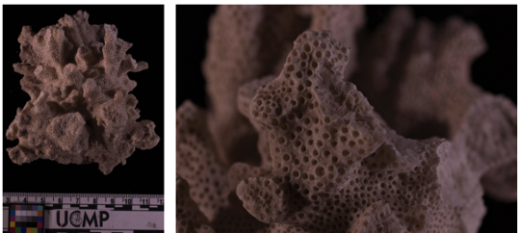

Concept 7: The present is the key to the past
7) Do fossils look like living things that you may have seen before?
Paleontologists are scientists who study fossils. Paleontologists look at organisms alive today for evidence about how the fossilized organism once lived.
A pill bug (left) is made up of many segments like an ancient trilobite (right).
Pill bugs and trilobites are both arthropods. An arthropod has its skeleton on the outside, a segmented body, many pairs of jointed legs, and bilateral symmetry.
The principle of uniformitarianism is that the present is the key to the past. This is the principle alluded to in the text above. This also gives student a chance to think about whether the fossil they’ve chosen looks like any living thing they have seen before.

Concept 8: Kinds of fossils
8) Here's how paleontologists find the name of a fossil. First, they figure out what kind of fossil it is. Kinds of fossils include: invertebrates (animals without a backbone), plants, vertebrates (animals with a backbone), or trace fossils showing evidence of past behavior.
This module focuses on marine invertebrate fossils because they are the focus of the EPICC grant. It is important for students to understand the main categories of fossils, which are presented here. Paleontologists usually specialize in one of these types of fossils (vertebrate, invertebrate, plant) rather than several of them.

All of the fossils so far have been invertebrate fossils.
This is a fossil scallop collected in California and is at least 2 million years old.
Scallop is the informal name for pectinid.

This is a plant fossil.
It is a maple leaf collected in Colorado and is at least 30 million years old.

This is a vertebrate fossil.
It is a synapsid. Collected in New Mexico, this fossil is at least 250 million years old.
This is most of a vertebrate skeleton. It is common to find only one bone from a vertebrate, in which case a paleontologist would compare the bone discovered to previous fossils or modern vertebrates to try to identify it.

The dark red shapes in this photo are three-toed dinosaur footprints. Footprints are an example of a trace fossil. Trace fossils provide evidence of an animal's behavior: in this case, walking.
These tracks found in Arizona are at least 200 million years old.

Concept 9: Classify your chosen fossil
9) If you found an invertebrate fossil, can you classify it? Is it a bivalve, echinoderm, coral, gastropod, arthropod or none of these? The photos below will help you decide.

This is a bivalve. A bivalve has two shells that fit together. The animal forms the shells and lives inside them.
This bivalve was collected in California and is at least 11,000 years old.

This is an echinoderm. Maybe you know the name sand dollar for this fossil? A sand dollar is an echinoderm.
This fossil was collected in California and is at least 2 million years old.

This is a fossil coral.
This fossil was collected in Panama and is at least 30 million years old.

This is a gastropod. A gastropod is an invertebrate that often makes its own twisted shell, such as a snail or abalone. A slug is a gastropod without a shell.
This gastropod was collected in Mexico and is at least 10,000 years old.

This is an arthropod, with its skeleton on the outside, a segmented body, many pairs of jointed legs, and bilateral symmetry.
This arthropod is called a trilobite, is from Canada, and is at least 485 million years old.
[caption] Trilobite means "three lobes." You can see the left pleural lobe, axial lobe and right pleural lobe here.

Concept 10: Identify your chosen fossil
10) Challenge: Do you want to find the name of your fossil? Use a field guide to look up possible names. Field guides help you narrow down what a fossil is based on its basic shape and other features. Here are some suggestions:
National Audubon Society Field Guides to Fossils
Smithsonian Handbooks: Fossils Edition 1
Field Guide to Devonian Fossils of New York
There may be a field guide to your local area describing the fossils.

Concept 11: Looking at geologic maps
11) Challenge: You can narrow down the list of names if you know where your fossil was collected.
If you know the geologic formation or rock unit where you found the fossil, you can look up what fossils have been previously discovered from that rock unit.

Geologic map of the Kettleman Hills, California
The colors on this map represent different geologic formations. Try finding a geologic map for your location on this page: https://ngmdb.usgs.gov/maps/mapview/
On the MapView website, there is a tool bar on the right hand side. Choose the bottom icon and you can enter a city name like Berkeley, CA to see maps for that area. You can zoom in closer on the map or click on the red diamond to see a list of maps. Learning to look at geologic maps takes some time, but would be a good exercise for high school or college students.

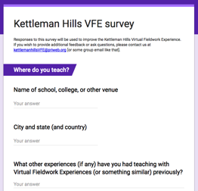
We would be grateful to receive feedback on how we could improve this virtual fieldwork experience. If you can spare about 10-15 minutes, please click here. Thank you very much.

