Field to Museum Virtual Field Experience
http://arcg.is/2k2wqfD

- Why do paleontologists collect fossils? Should you collect every fossil you find? Why or why not? Write your answer in your field notebook.
- If you are on US Forest Service land, can you collect common invertebrate fossils? If you are on US Forest Service land, can you collect vertebrate fossils? Can you collect any fossils on National Park Service land? Write your answer in your field notebook.

3a) Imagine you and two friends went to the Kettleman Hills to look at fossils. (Please note that the Kettleman Hills localities are on private land and no longer available to collectors.) Write down your name, the name of those with you, today’s date, what the weather is like today (warm or cold, sunny or rainy) and the location: Pseudocardium zone of the Etchegoin Formation.

3b) Choose a photograph of exposed rocks with a person or tool for scale from this webpage:
https://flic.kr/s/aHskX78qoh
For example, I chose the photo below:
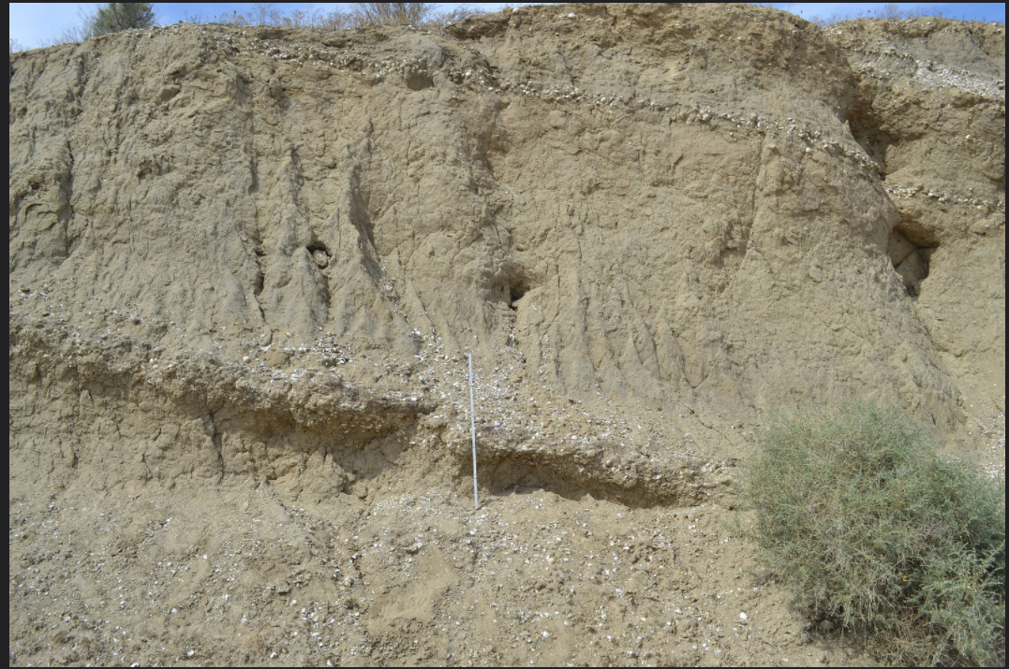
Write down your observations about the sediment and the fossils. Do you see the layers of white shells in between layers of brown sedimentary rock in this photo? Draw lines on either side of the layers of white shells.

3c) Make a drawing of the outcrop in your notebook. Label any fossils you can see. You may want to draw a simple shell as a symbol for where fossils are found in your drawing, see the example below.

4a) Find two other photos of the Pseudocardium zone outcrop on this page:
https://flic.kr/s/aHskX78qoh
Explain why you chose those photos including whether the photos include a scale and features that won’t move over time.

4b) Find two close-up photo of fossils from the Pseudocardium zone outcrop on this page:
https://flic.kr/s/aHskX78qoh
Explain why you chose those photos including whether the photos include an object for scale.

5) Write down captions for the four photos you chose above. Use the information from your field notebook and choose yourself or one of your two friends as the person who took the photos or is in the photos. Make sure you include the date and the time the photo was taken. Describe the rocks or fossils you can see in the photo. The rock exposures are from the Pseudocardium (a fossil bivalve) zone of the Purisima Formation.

If you have a printer, print out one of the outcrop photos and draw an arrow showing where there are fossils visible.

6) If you have internet access, visit Google Earth https://www.google.com/earth and enter “Kettleman Hills” where the magnifying glass signifies “search” and see what the area looks like. Find an area with exposed rock or sediment where you could find a fossil. If you have a printer, print out a picture and mark the place you “collected” the fossil with a small circle.

7) Choose one of your two close-up photos of fossils from the Pseudocardium zone. Describe the rocks above, below and near the fossil in your field notebook. Does your fossil have any parts that look delicate? Based on the video of fossil collecting, describe how you would wrap the fossil in your photo.

8) Write down what your field number for this locality would be. Remember to use your initials, the date and the fossil’s position in the list of fossils collected that day. Look at the labeling guide and explain where you would a number on your fossil, in order to avoid covering any features used for identification.

9a) Is your fossil an important fossil? What evidence supports your claim? (Hint: use the What is a Fossil? Module to try to identify your fossil.)

9b) Would you choose to donate your fossil to a museum? Why or why not? If not, what would you do with the fossil?

10) View the online record for the fossil in the photo. What county was this fossil collected in? What formation is this fossil from? What is the name of the fossil (hint: look at the left side of webpage for the genus and species name)?

